

2022 - 23

2022 -23

478

CHAUHAN

ASHUTOSH SINGH

TYBSC - CS

2020874

VI

**INDEX**

|  |  |  |
| --- | --- | --- |
| **No** | **Title** | **Page No.** |
| 1 | Practical of Data collection, Data curation and management for Large-scale Data system (such as MongoDB) CRUD operations using MongoDB | 2 |
| 2 | Demonstration of Linear Regression | 7 |
| 3 | Demonstration of Logistic Regression | 9 |
| 4 | Demonstration of Hypothesis Testing | 15 |
| 5 | Demonstration of ANOVA | 19 |
| 6 | Demonstration of Decision Tree | 23 |
| 7 | Demonstration of PCA | 30 |
| 8 | Demonstration of Clustering | 38 |
| 9 | Demonstration of Time Series Forecasting | 46 |
| 10 | Use of R Markdown and RStudio Cloud | 55 |

**Practical No : 1**

**AIM :** Practical of Data Collection, Data Curation and Management for large scale data system (such as MongoDB).

**Theory :**

MongoDB is an open source NoSQL database management program. NoSQL is used as an alternative to traditional relational databases. NoSQL databases are quite useful for working with large sets of distributed data. MongoDB is a tool that can manage document-oriented information, store or retrieve information.

A collection is a grouping of MongoDB documents. Documents within a collection can have different fields. A collection is the equivalent of a table in a relational database system. A collection exists within a single database.

**MongoDB Features**

* Ad-hoc queries for optimized, real-time analytics. ...
* Indexing appropriately for better query executions. ...
* Replication for better data availability and stability. ...
* Sharding. ...
* Load balancing.

**Create Operations**

Create or insert operations add new [documents](https://www.mongodb.com/docs/manual/core/document/#std-label-bson-document-format) to a [collection](https://www.mongodb.com/docs/manual/core/databases-and-collections/#std-label-collections). If the collection does not currently exist, insert operations will create the collection.

MongoDB provides the following methods to insert documents into a collection:

* [db.collection.insertOne()](https://www.mongodb.com/docs/manual/reference/method/db.collection.insertOne/#mongodb-method-db.collection.insertOne)
* [db.collection.insertMany()](https://www.mongodb.com/docs/manual/reference/method/db.collection.insertMany/#mongodb-method-db.collection.insertMany)

In MongoDB, insert operations target a single [collection](https://www.mongodb.com/docs/manual/reference/glossary/#std-term-collection). All write operations in MongoDB are [atomic](https://www.mongodb.com/docs/manual/core/write-operations-atomicity/) on the level of a single [document.](https://www.mongodb.com/docs/manual/core/document/)

**Read Operations**

Read operations retrieve [documents](https://www.mongodb.com/docs/manual/core/document/#std-label-bson-document-format) from a [collection](https://www.mongodb.com/docs/manual/core/databases-and-collections/#std-label-collections); i.e. query a collection for documents. MongoDB provides the following methods to read documents from a collection:

* [db.collection.find()](https://www.mongodb.com/docs/manual/reference/method/db.collection.find/#mongodb-method-db.collection.find)

You can specify [query filters or criteria](https://www.mongodb.com/docs/manual/tutorial/query-documents/#std-label-read-operations-query-argument) that identify the documents to return.

**Update Operations**

Update operations modify existing [documents](https://www.mongodb.com/docs/manual/core/document/#std-label-bson-document-format) in a [collection](https://www.mongodb.com/docs/manual/core/databases-and-collections/#std-label-collections). MongoDB provides the following methods to update documents of a collection:

* [db.collection.updateOne()](https://www.mongodb.com/docs/manual/reference/method/db.collection.updateOne/#mongodb-method-db.collection.updateOne)
* [db.collection.updateMany()](https://www.mongodb.com/docs/manual/reference/method/db.collection.updateMany/#mongodb-method-db.collection.updateMany)
* [db.collection.replaceOne()](https://www.mongodb.com/docs/manual/reference/method/db.collection.replaceOne/#mongodb-method-db.collection.replaceOne)

In MongoDB, update operations target a single collection. All write operations in MongoDB are [atomic](https://www.mongodb.com/docs/manual/core/write-operations-atomicity/) on the level of a single document.

You can specify criteria, or filters, that identify the documents to update. These [filters](https://www.mongodb.com/docs/manual/core/document/#std-label-document-query-filter) use the same syntax as read operations.

**Delete Operations**

Delete operations remove documents from a collection. MongoDB provides the following methods to delete documents of a collection:

* [db.collection.deleteOne()](https://www.mongodb.com/docs/manual/reference/method/db.collection.deleteOne/#mongodb-method-db.collection.deleteOne)
* [db.collection.deleteMany()](https://www.mongodb.com/docs/manual/reference/method/db.collection.deleteMany/#mongodb-method-db.collection.deleteMany)

In MongoDB, delete operations target a single [collection](https://www.mongodb.com/docs/manual/reference/glossary/#std-term-collection). All write operations in MongoDB are [atomic](https://www.mongodb.com/docs/manual/core/write-operations-atomicity/) on the level of a single document.

You can specify criteria, or filters, that identify the documents to remove. These [filters](https://www.mongodb.com/docs/manual/core/document/#std-label-document-query-filter) use the same syntax as read operations.

**CODE:**

To Create and delete DB tes

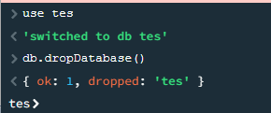

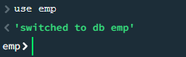

Create Collection using db.createCollection(“collectionname”)

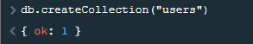

Delete collection

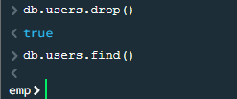

Insert data into collections

Using one input

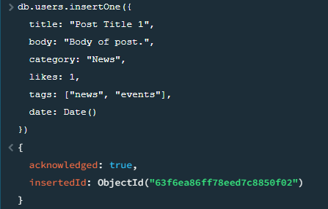

 Using many inputs

db.posts.insertMany([

  {

    title: "Post Title 2",

    body: "Body of post.",

    category: "Event",

    likes: 2,

    tags: ["news", "events"],

    date: Date()

  },

  {

    title: "Post Title 3",

    body: "Body of post.",

    category: "Technology",

    likes: 3,

    tags: ["news", "events"],

    date: Date()

  },

  {

    title: "Post Title 4",

    body: "Body of post.",

    category: "Event",

    likes: 4,

    tags: ["news", "events"],

    date: Date()

  }

])

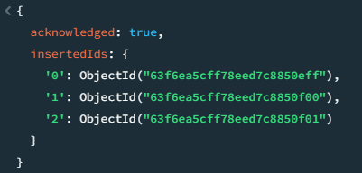

Delete multiple data using category

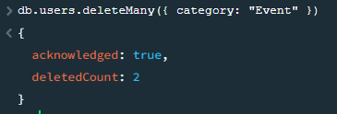

Delete single data

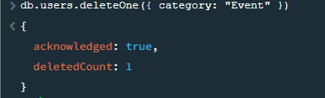

To view all the data use th find()

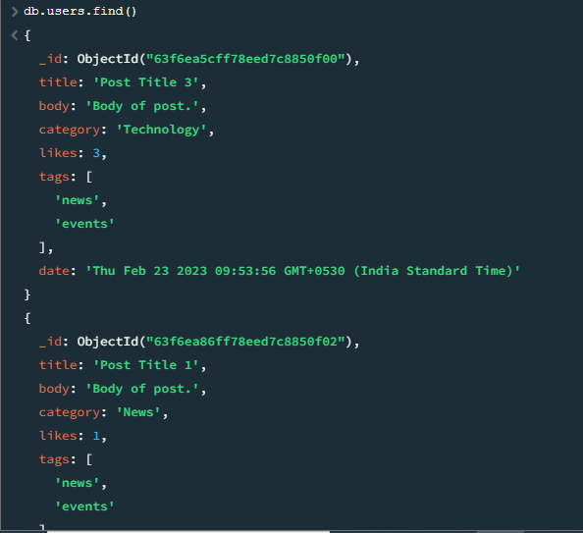

Update the likes

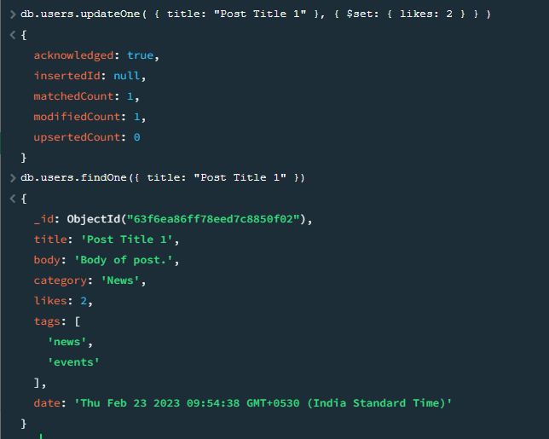

**Conclusion :** MongoDB is a non-relational document database that provides support for JSON-like storage. The MongoDB database has a flexible data model that enables you to store unstructured data, and it provides full indexing support, and replication with rich and intuitive APIs.

e

**Practical 2**

**Aim – Demo of Simple/Multiple Linear Regression**

**Theory –**

1. Simple Linear Regression:

Simple linear regression is used to estimate the relationship between two quantitative variables. You can

use simple linear regression when you want to know:

• How strong the relationship is between two variables (e.g., the relationship between rainfall and

soil erosion).

• The value of the dependent variable at a certain value of the independent variable (e.g., the

amount of soil erosion at a certain level of rainfall).

Regression models describe the relationship between variables by fitting a line to the observed data.

Linear regression models use a straight line, while logistic and nonlinear regression models use a curved

line. Regression allows you to estimate how a dependent variable changes as the independent variable(s)

change.

For Eg:

You are a social researcher interested in the relationship between income and happiness. You survey 500people whose incomes range from 15k to 75k and ask them to rank their happiness on a scale from 1 to10.Your independent variable (income) and dependent variable (happiness) are both quantitative, so you cando a regression analysis to see if there is a linear relationship between them.

Code: 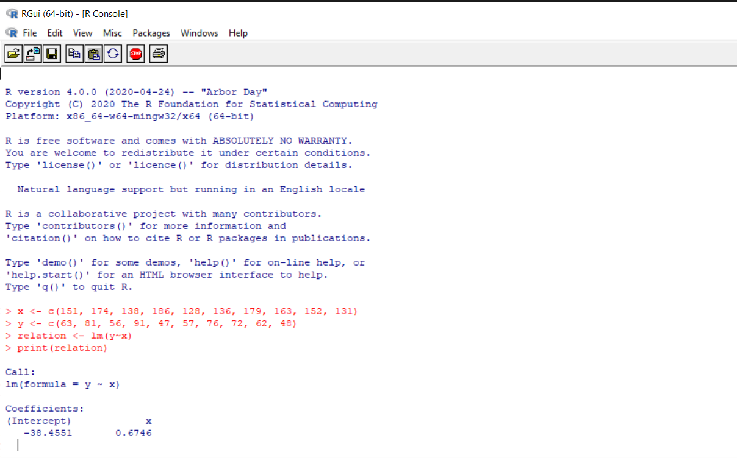

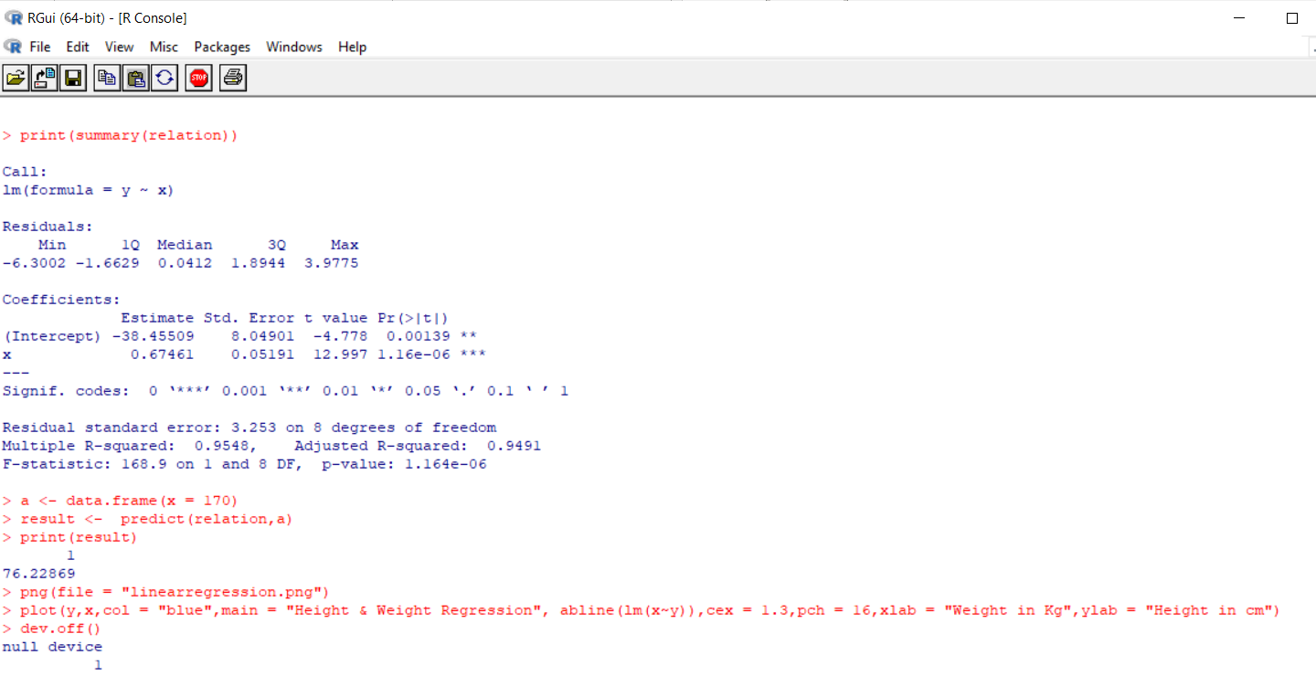

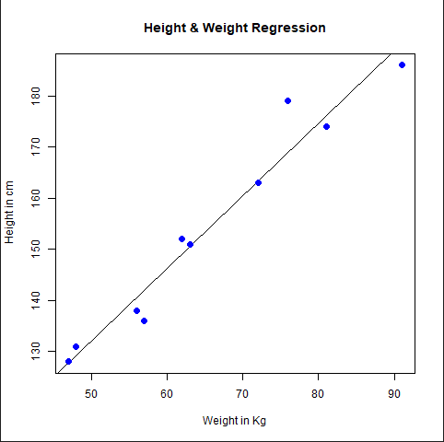

**Practical 3**

**Aim – Demo of Logistic Regression**

**Theory –**

Logistic regression is a statistical analysis method to predict a binary outcome, such as yes or no, based on prior observations of a data set.

A logistic regression model predicts a dependent data variable by analyzing the relationship between one or more existing independent variables. For example, a logistic regression could be used to predict whether a political candidate will win or lose an election or whether a high school student will be admitted or not to a particular college. These binary outcomes allow straightforward decisions between two alternatives.

A logistic regression model can take into consideration multiple input criteria. In the case of college

acceptance, the logistic function could consider factors such as the student's grade point average, SAT score and number of extracurricular activities. Based on historical data about earlier outcomes involving the same input criteria, it then scores new cases on their probability of falling into one of two outcome categories.

Logistic regression has become an important tool in the discipline of machine learning. It allows algorithms used in machine learning applications to classify incoming data based on historical data. As additional relevant data comes in, the algorithms get better at predicting classifications within data sets.

Logistic regression can also play a role in data preparation activities by allowing data sets to be put into specifically predefined buckets during the extract, transform, load (ETL) process in order to stage the information for analysis.

Code.

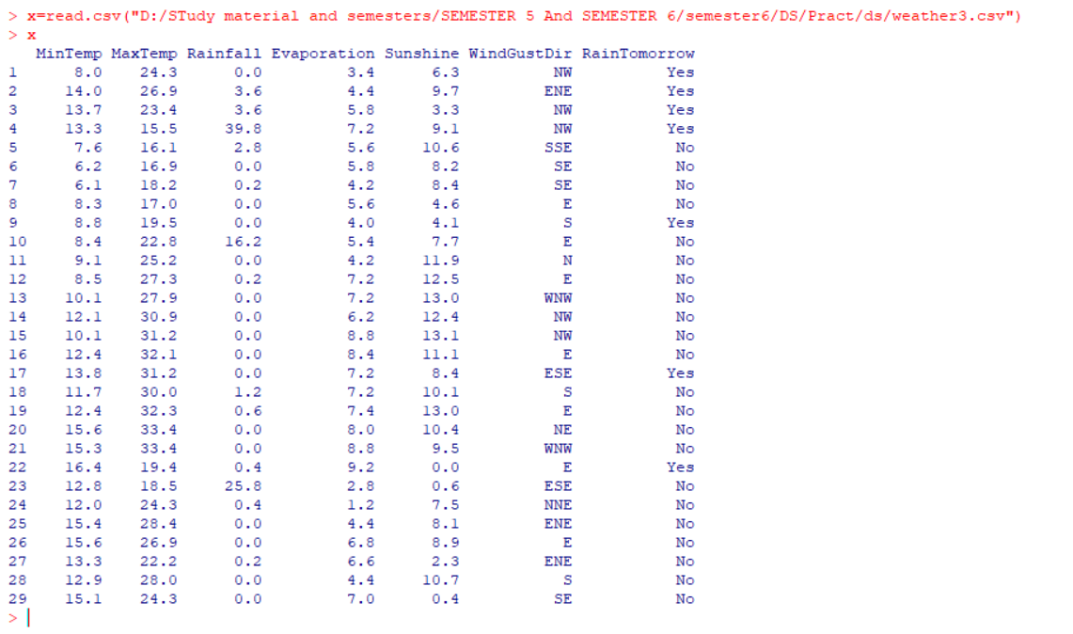

**PRINTING THE DATASET**

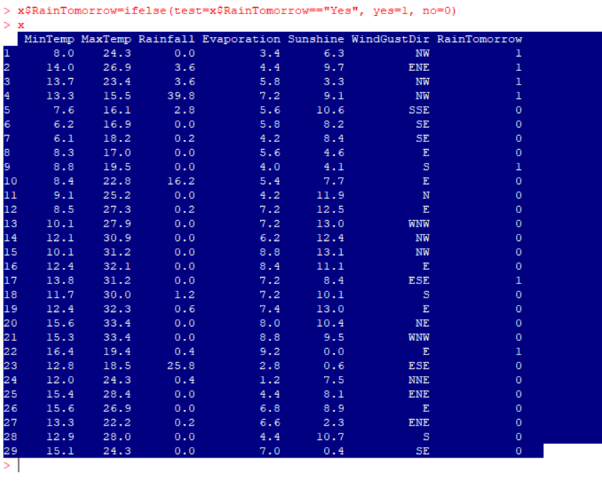

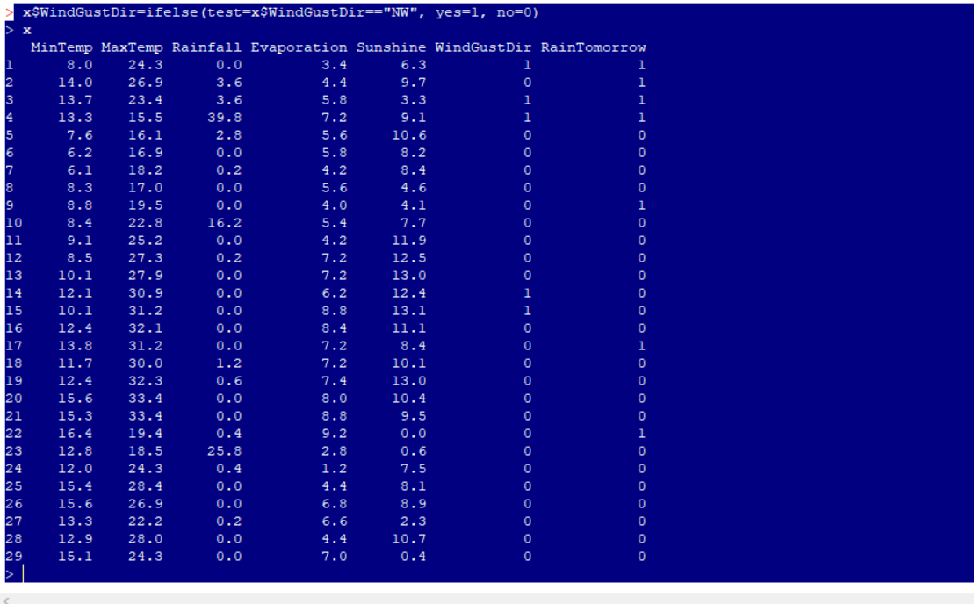

**PARTIONING DATASET**

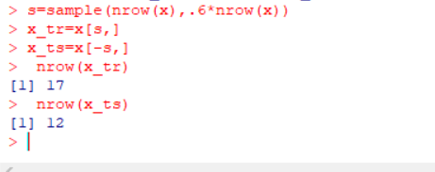

**DATA MODELING**

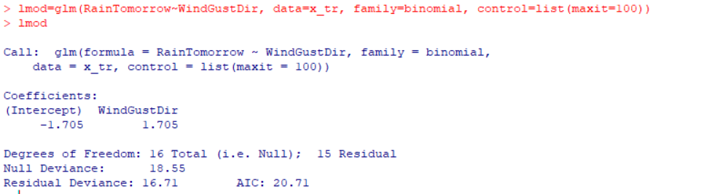

**#SUMMARY**

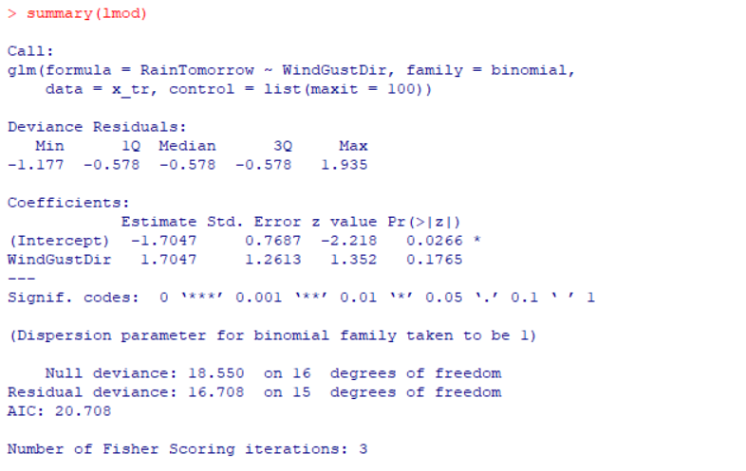

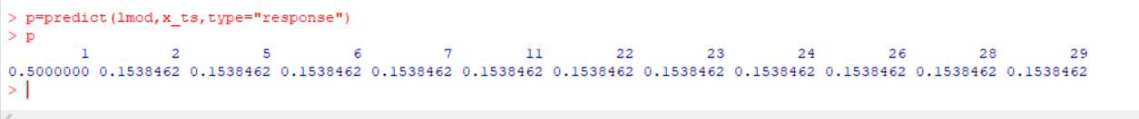

**SECOND DATA SET:**

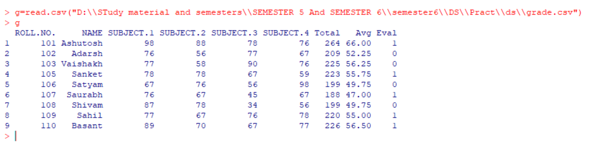

**PARTIONING DATASET**

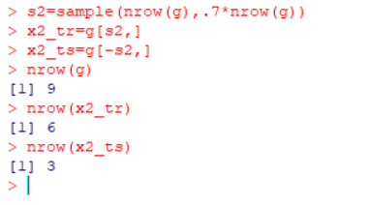

**DATA MODELING**

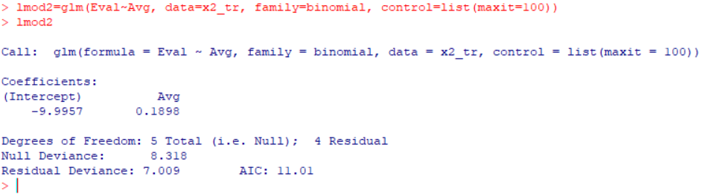

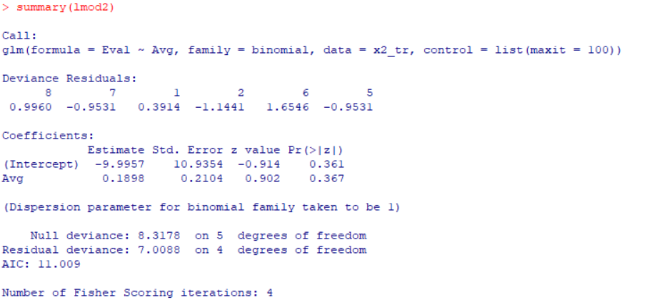

**#PREDICTION:**

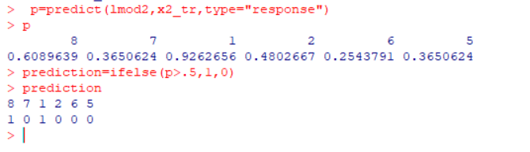**PREDICTION MATRIX**

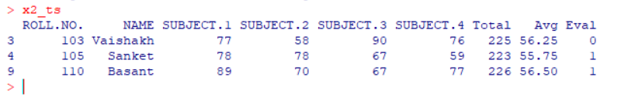**#actuals predicted**

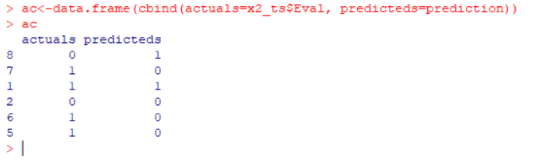

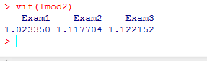

**CONCLUSION** : Logistic regression is one of the most popular Machine Learning algorithms, which comes under the Supervised Learning technique. It is used for predicting the categorical dependent variable using a given set of independent variables.Logistic regression predicts the output of a categorical dependent variable. Therefore the outcome must be a categorical or discrete value. It can be either Yes or No, 0 or 1, true or False, etc. but instead of giving the exact value as 0 and 1, it gives the probabilistic values which lie between 0 and1.

**Practical : 4**

**AIM:** Practical of Hypothesis testing.

**A.**Hypothesis testing of a Single Population means.

Hypothesis testing is a form of statistical inference that uses data from a sample to draw conclusions about apopulation parameter or a population probability distribution.First, a tentative assumption is made about the parameter or distribution. This assumption is called the null hypothesis and is denoted by H0. An alternative hypothesis (denoted Ha), which is the opposite of what is stated in the null hypothesis, is then defined. The hypothesis-testing procedure involves using sample data todetermine whether or not H0 can be rejected. If H0 is rejected, the statistical conclusion is that the alternativehypothesis Ha is true.**Step 1:** First we have to create Excel file and Enter the 28 values so that we can fine deviation, Square of deviation, population, differentiate of mean, T-value, and system .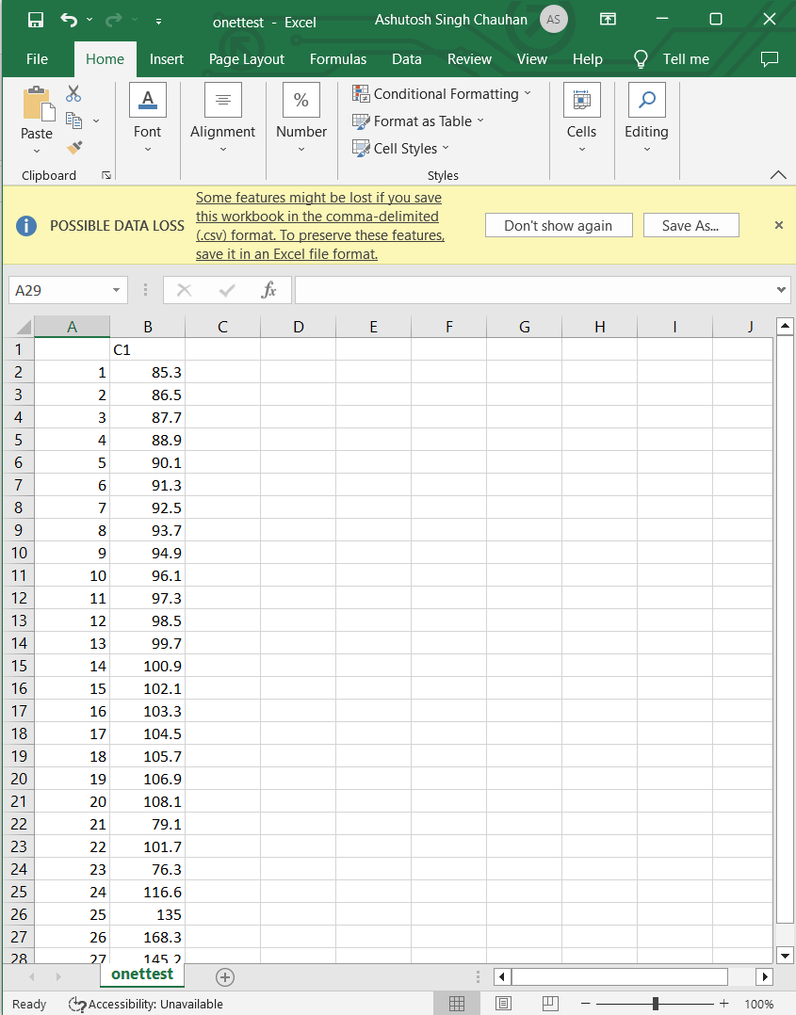

Step 2:Now we have to import Excel file (onetest.csv) type bellow command.

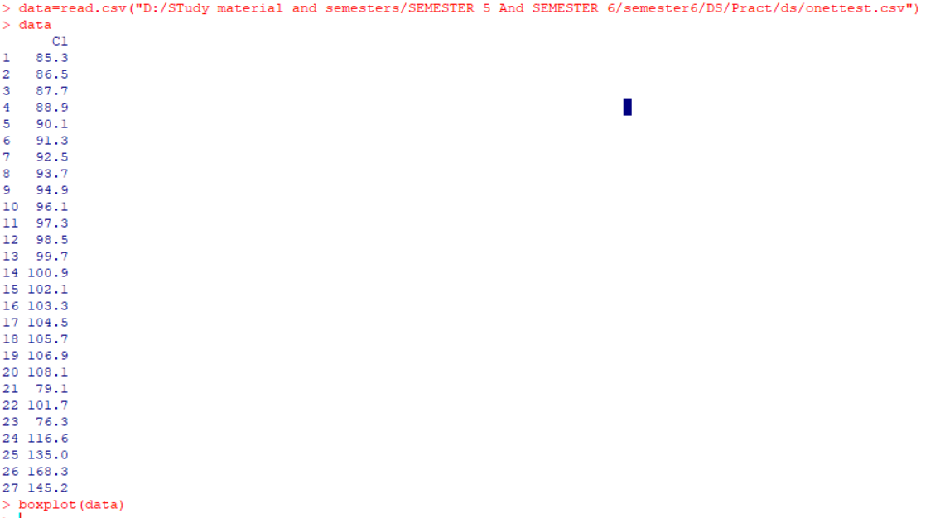

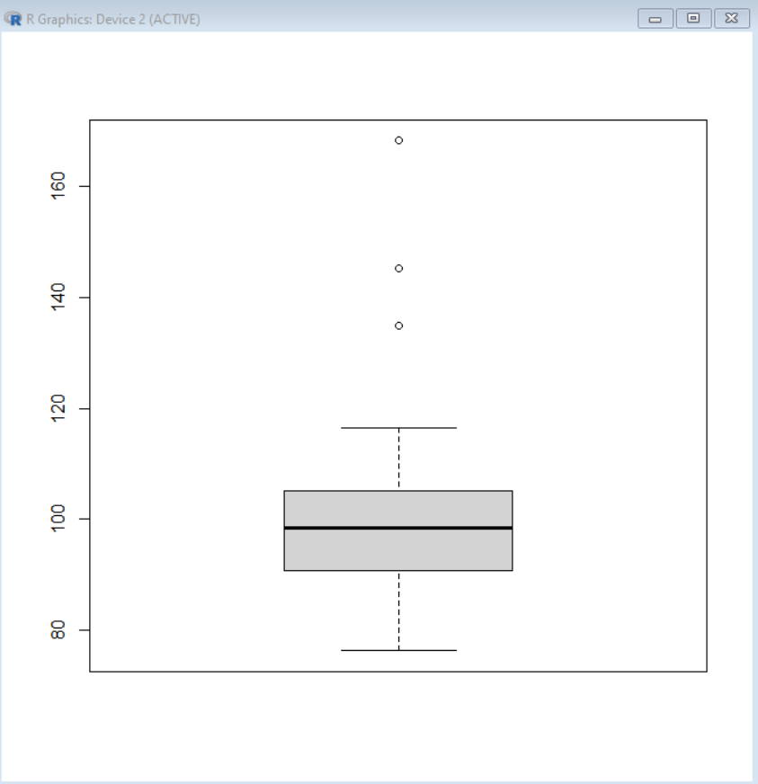

Step 3:After that find mean of respective data

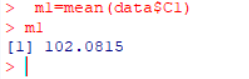

Step 4:Now calculate the standard deviation.

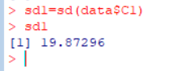

Step 5:Plot bell curve.

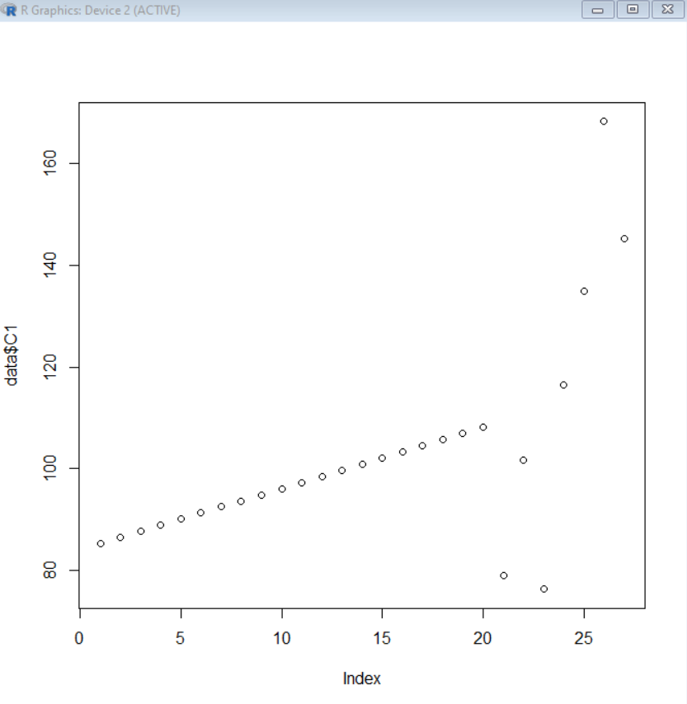

Step 6: At the end find T-Test value type following command.

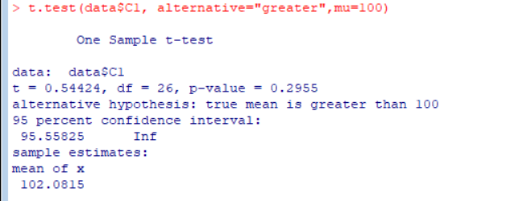

**CONCLUSION:**Thus we have implemented Hypothesis testing of a Single Population means successfully.

**Practical No 5**

**Aim: Demonstration of Analysis of Variance**.

Theory: Analysis of variance (ANOVA) is an analysis tool used in statistics that splits an observed aggregate variability found inside a data set into two parts: systematic factors and random factors. The systematic factors have a statistical influence on the given data set, while the random factors do not.

Code :

# CREATE THE DATA IN TO THREE GROUPS TO PRINT THE BOXPLOT

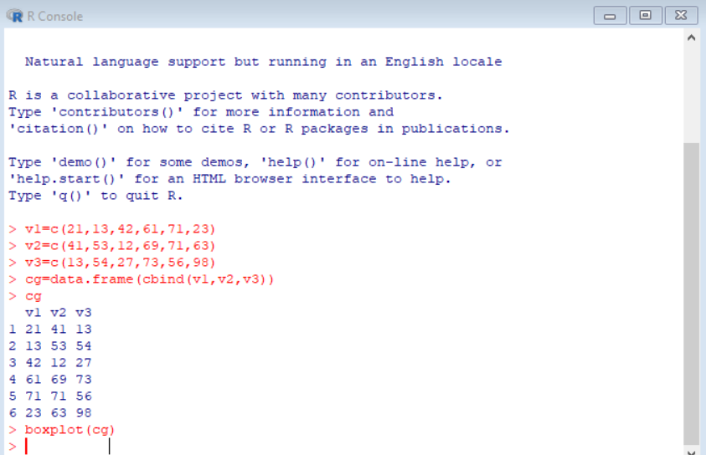

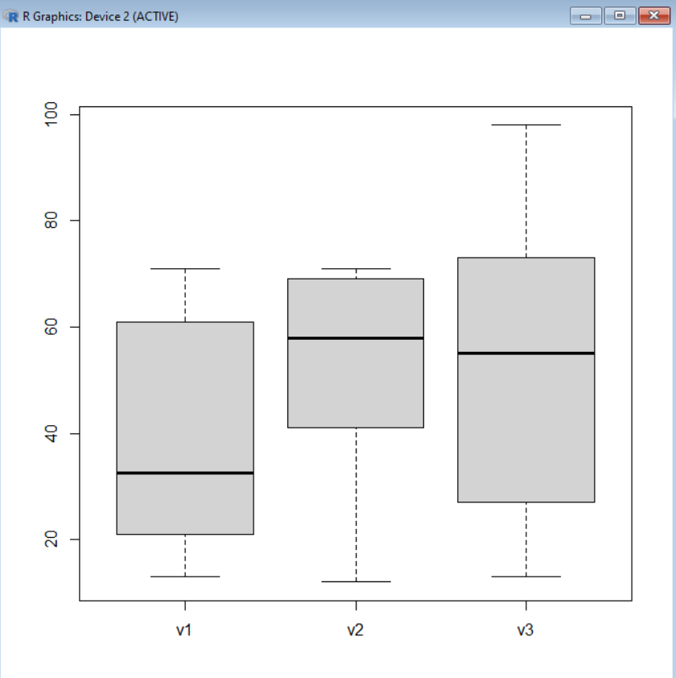

#TO PRINT THE DATA INTO STACK FORMATE

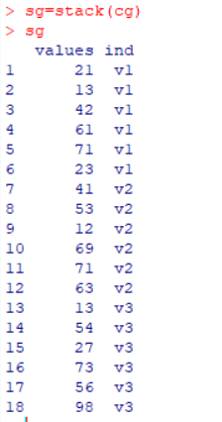

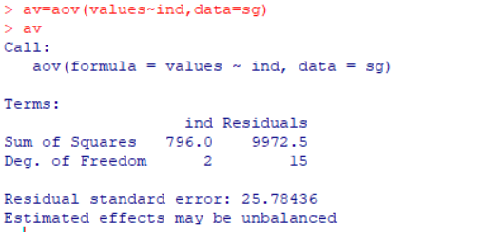 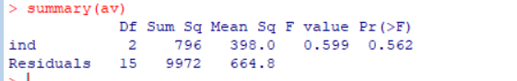

TAKE ANOTHER DATASET AND WORK ON THAT.

# CREATE THE DATA IN TO THREE GROUPS

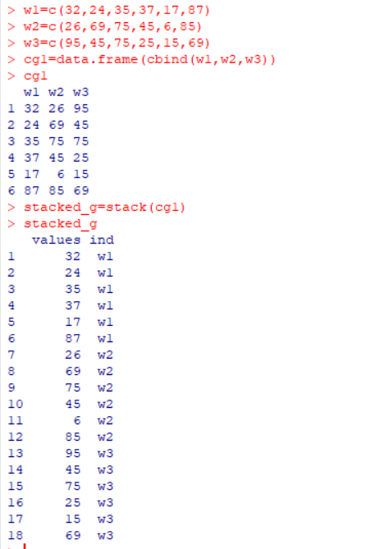

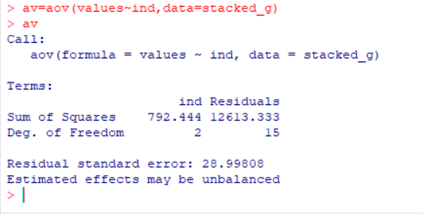

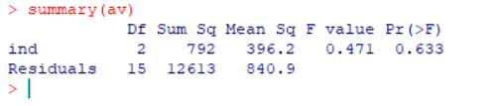

**Conclusion :** Successfully Implemented Varience……

**Practical No: 6**

**Aim:Demo of Decision Tree.**

**Theory**: A decision tree is a flowchart-like tree structure where an internal node represents feature(or attribute), the branch represents a decision rule, and each leaf node represents the outcome. The topmost node in a decision tree is known as the root node. It learns to partition on the basis of the attribute value. It partitions the tree in recursively manner call recursive partitioning. This flowchart-like structure helps you in decision making. It's isualization like a flowchart diagram which easily mimics the human level thinking. That is why decision trees are easy to understand and interpret.

**Code:**

Step1: click on packages and set cran mirror.

Step2: click on packages and select install packages and install 3 packages (rpart,tree,rattle)

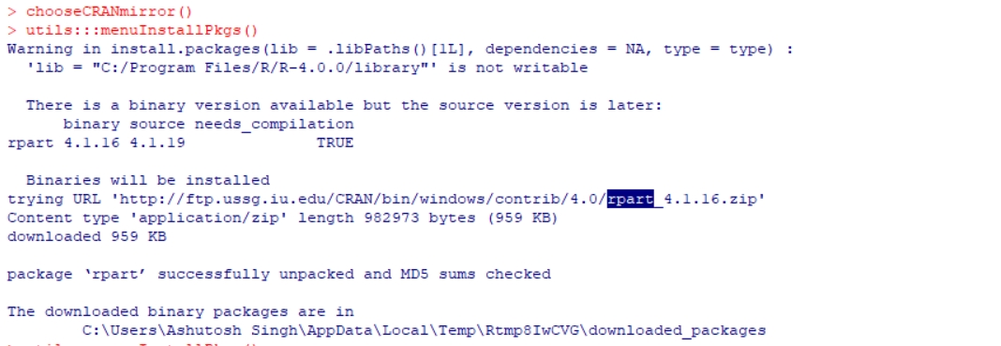

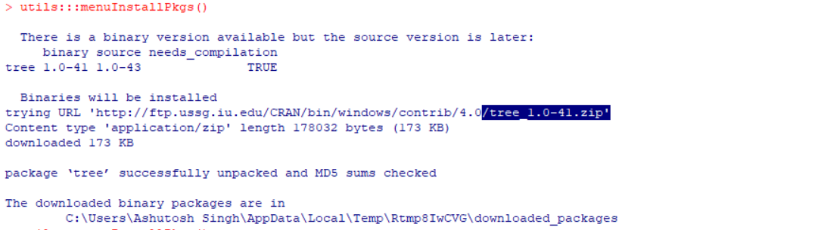

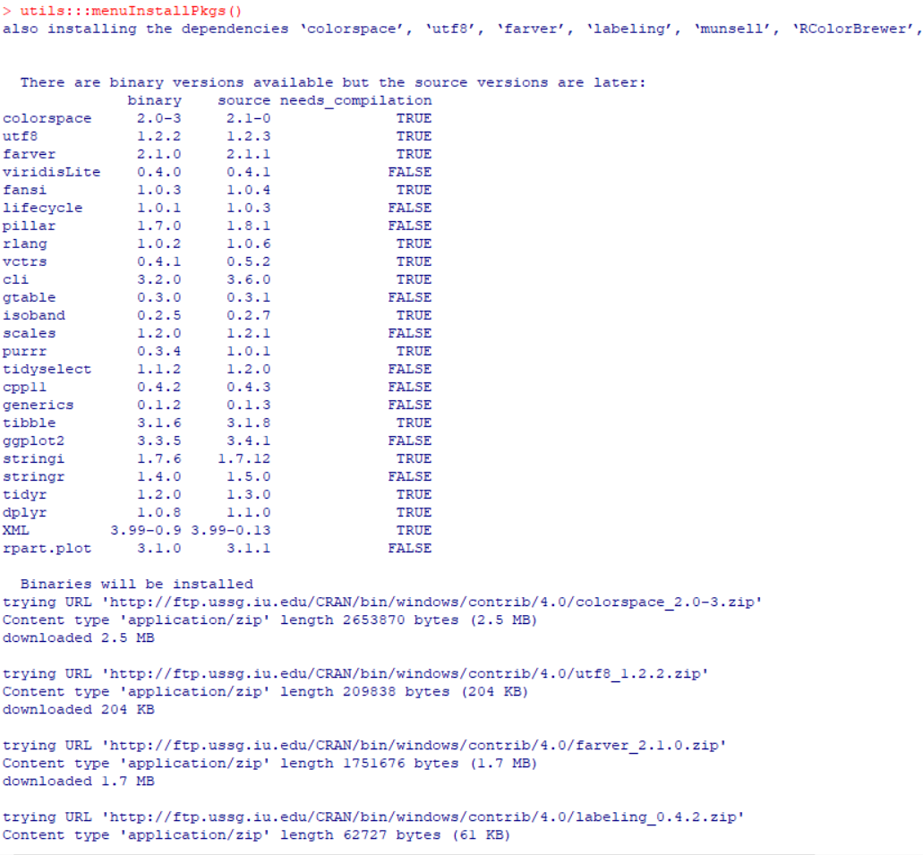

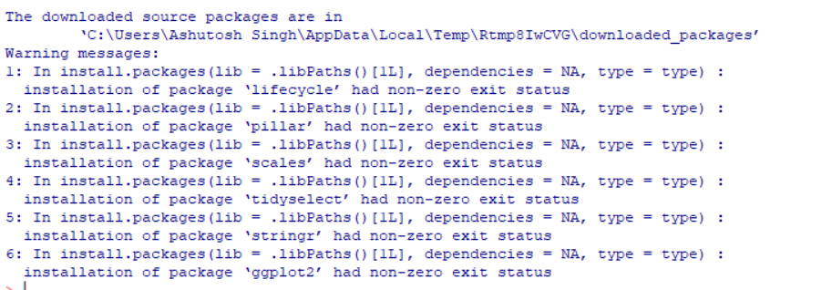

* **Create an excel data save it with .csv extension.**

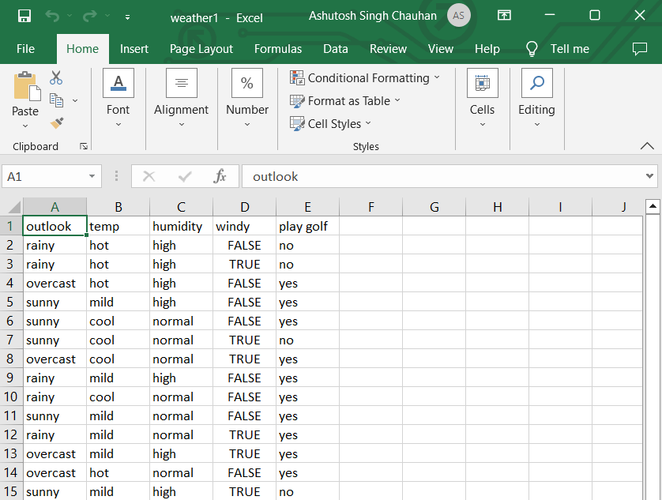

**Read excel data**

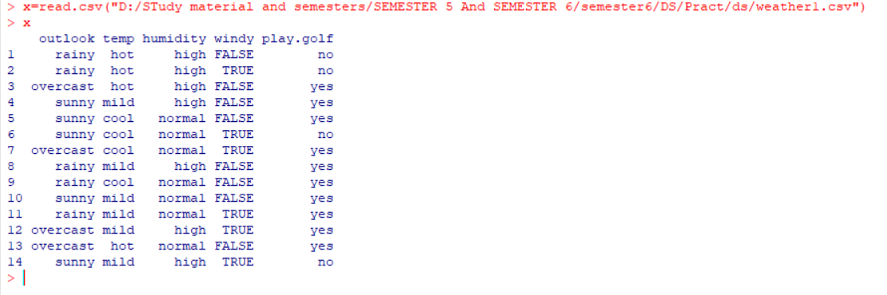

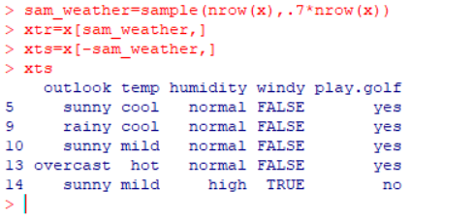

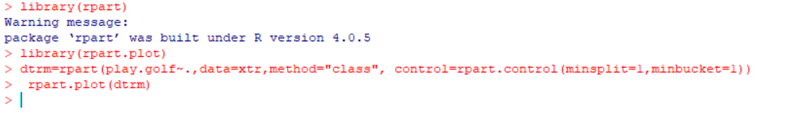

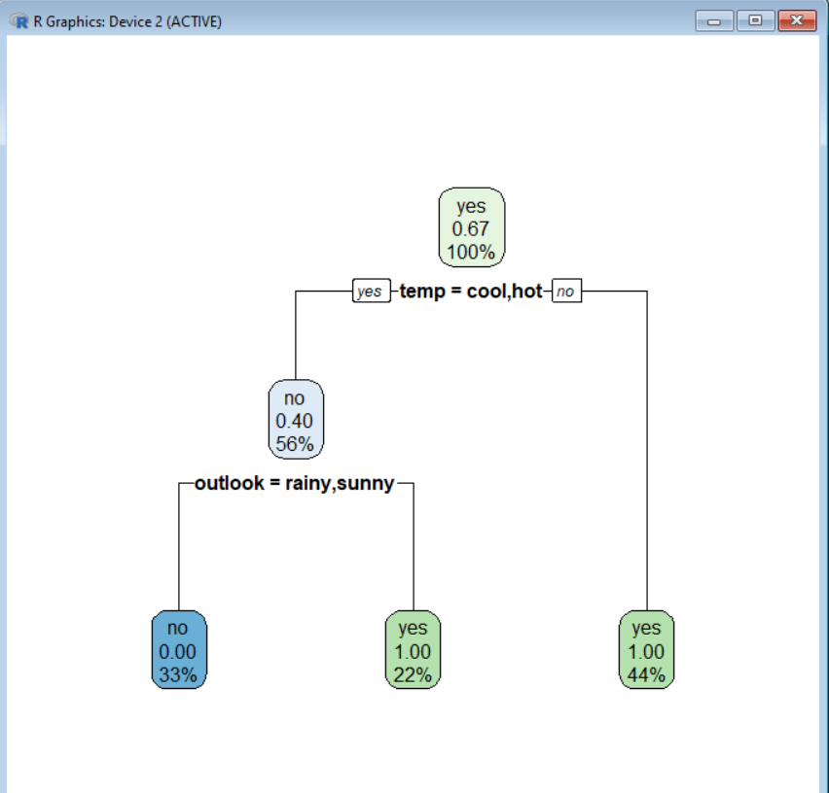

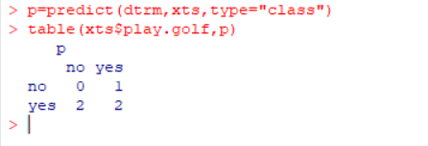

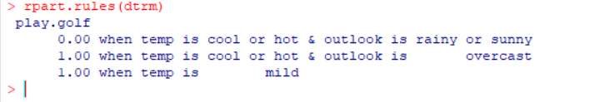 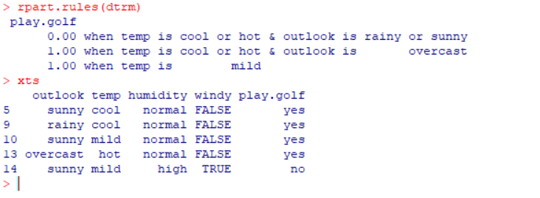

**Regression Tree:**

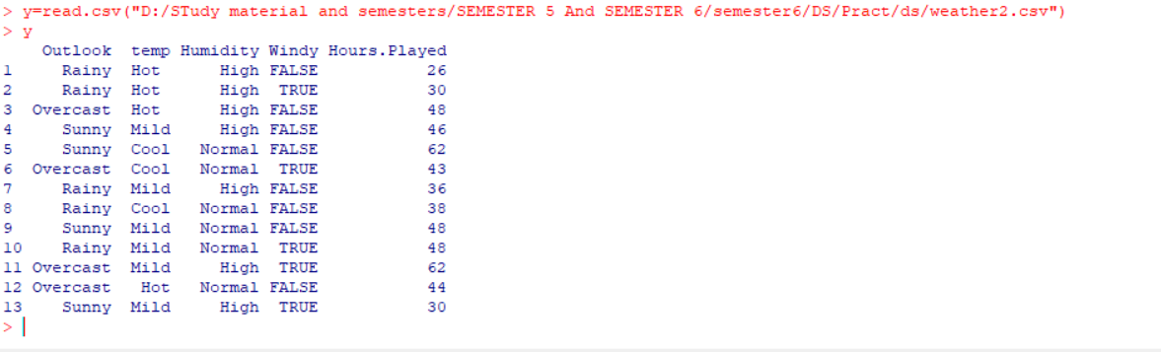

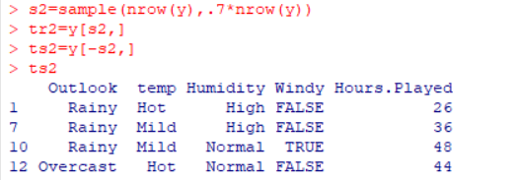

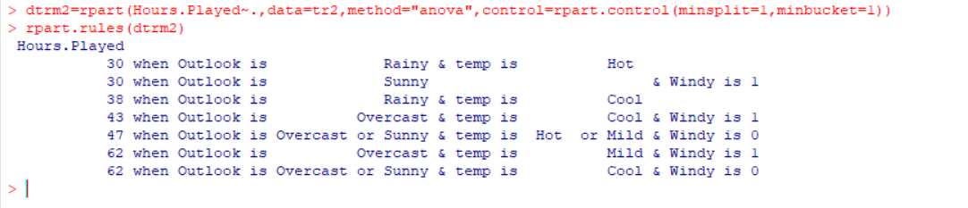

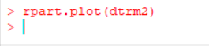

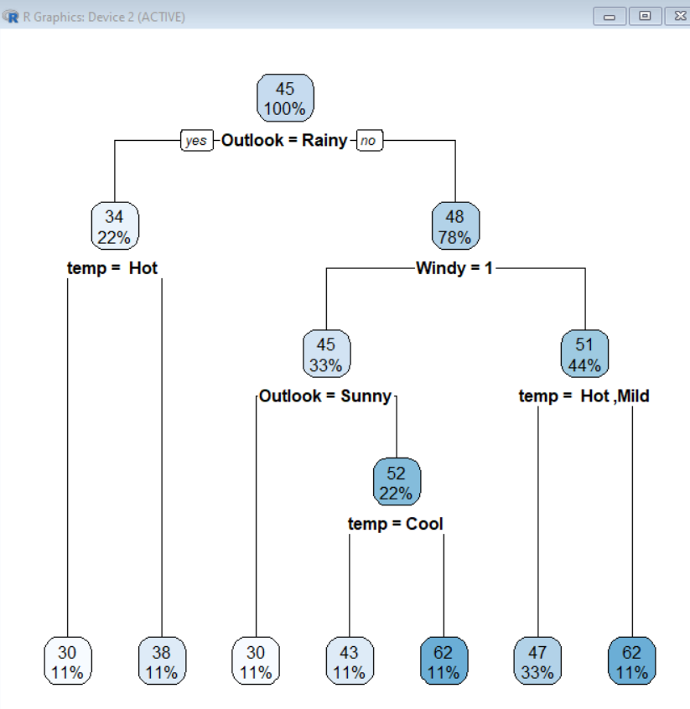

**Prediction:**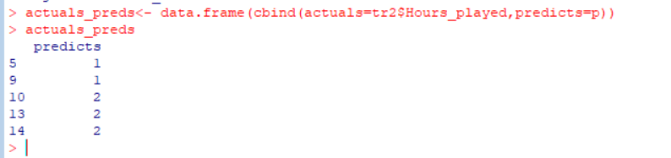

**Conclusion: Successfully Implemented Decision Tree…**

**Practical : 07**

**Aim**: Demo of Principal component analysis.

Theory : Principal Component Analysis is basically a statistical procedure to convert a set of observations of possibly correlated variables into a set of values of linearly uncorrelated variables. Each of the principal components is chosen in such a way so that it would describe most of them still available variance and all these principal components are orthogonal to each other. In all principal components first principal component has a maximum variance.

Uses of PCA:

• It is used to find inter-relation between variables in the data.

• It is used to interpret and visualize data.

• The number of variables is decreasing it makes further analysis simpler.

• It’s often used to visualize genetic distance and relatedness between populations.

Code:

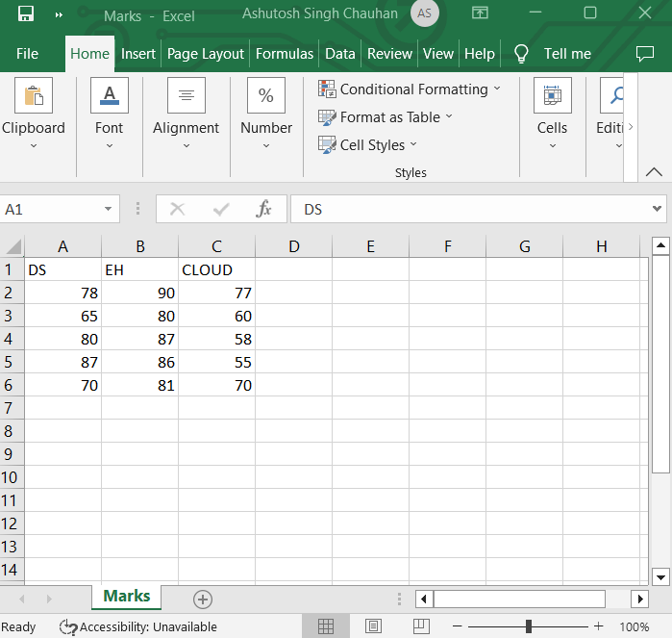

> install.packages(“FactoMineR”)

> install.packages(“factoextra”)

> library(“FactoMineR”)

> library(“factoextra”)

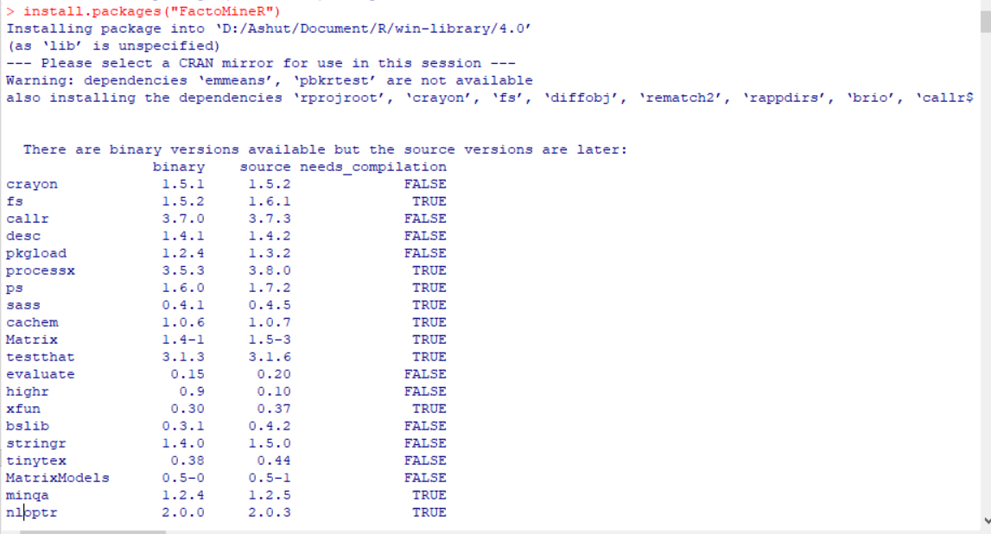 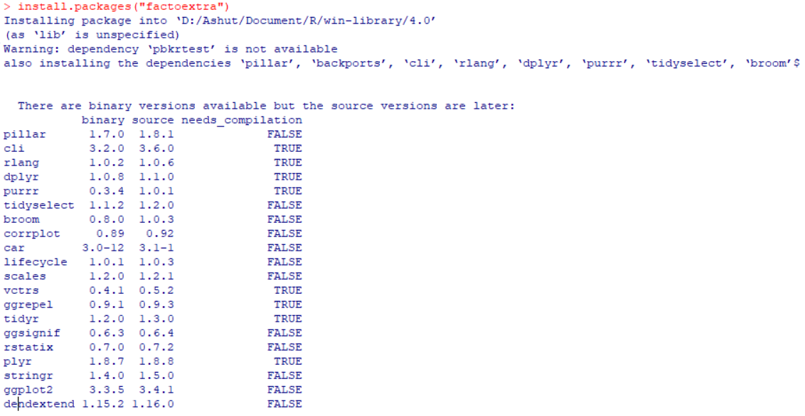 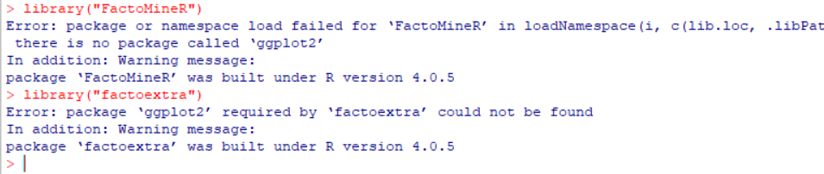

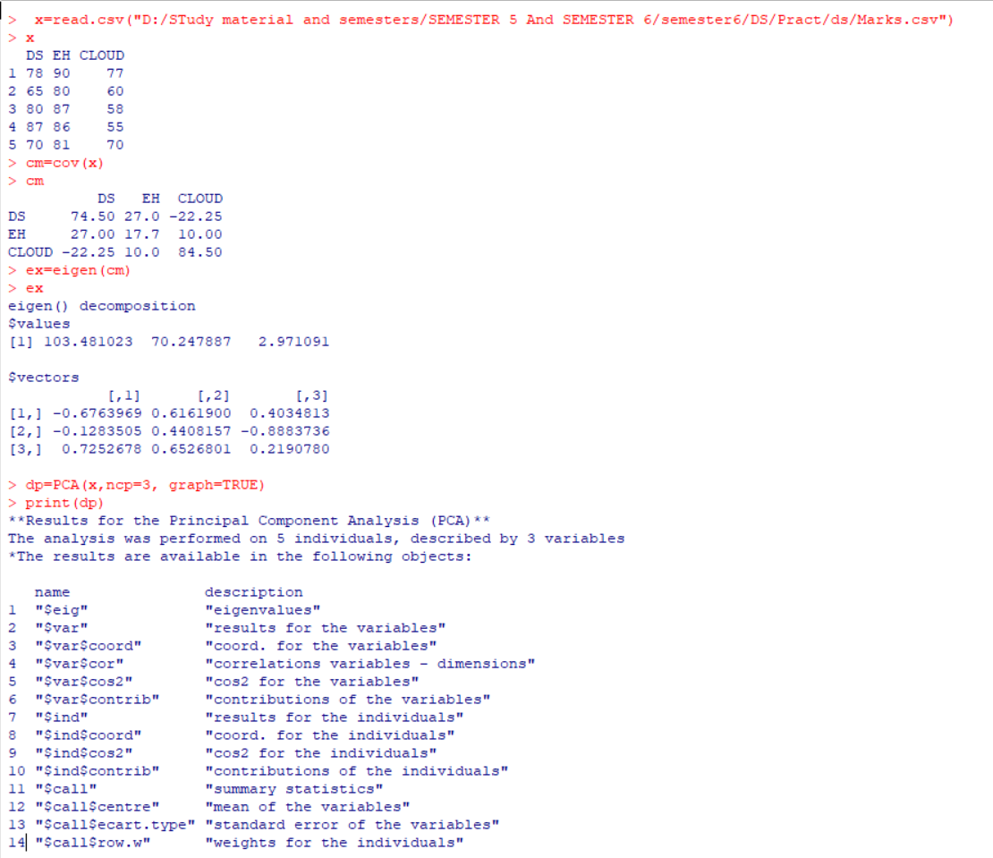 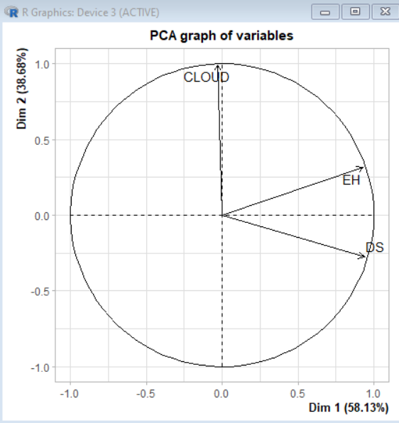

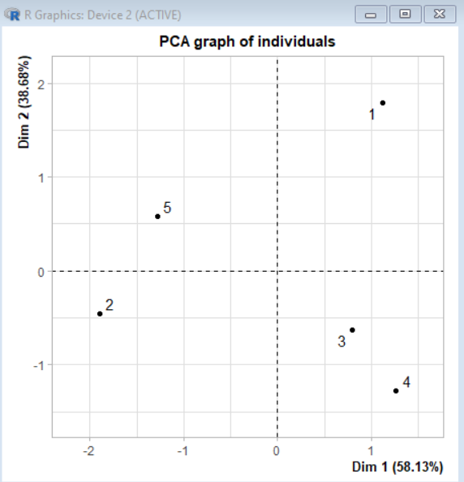

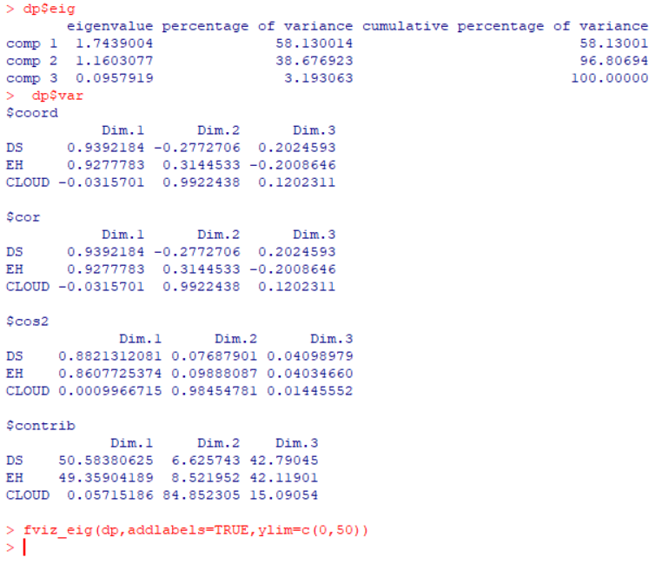

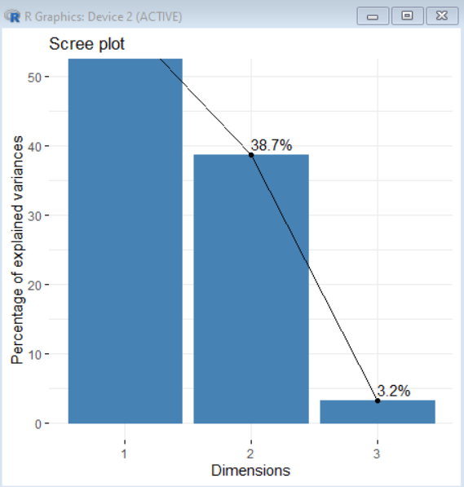

Implementing PCA on IRIS dataset

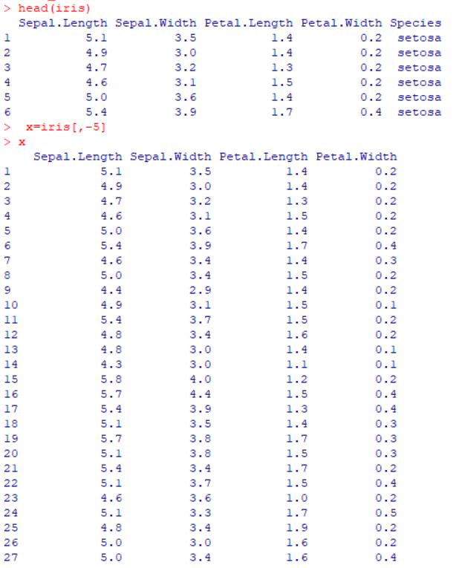

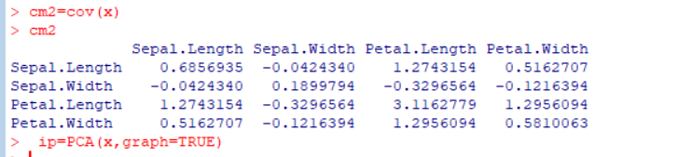

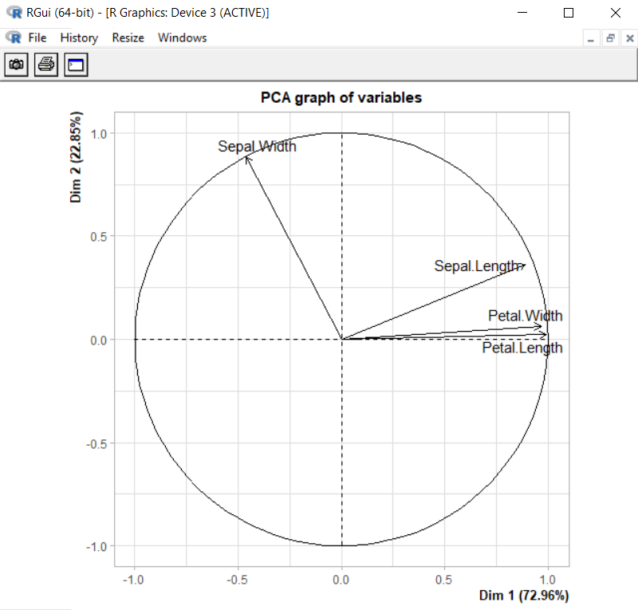

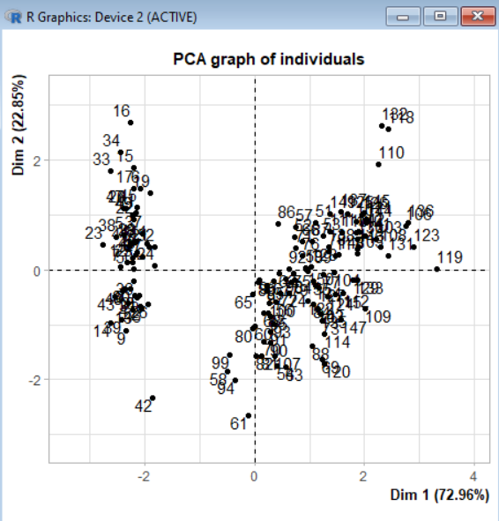 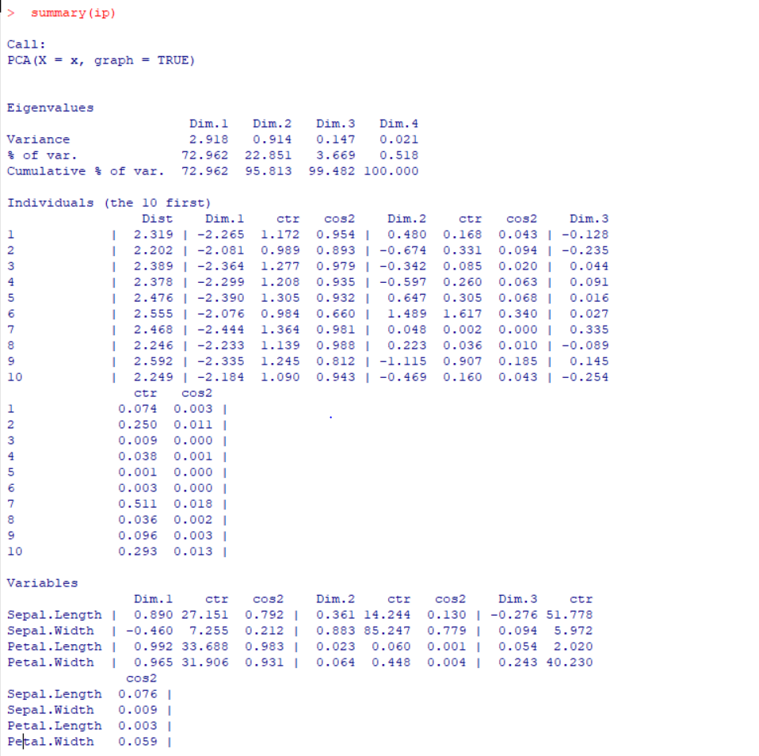

**Conclusion :** Principal component analysis (PCA) is a popular technique for analyzing large datasets containing a high number of dimensions/features per observation, increasing the interpretability of data while preserving the maximum amount of information, and enabling the visualization of multidimensional data.

**Practical : 08**

**AIM:** **Demo of Clustering.**

Theory : K-means Clustering Algo:

K-means is an unsupervised learning method for clustering data points. The algorithm iteratively divides data points into K clusters by minimizing the variance in each cluster.

How does it work?

First, each data point is randomly assigned to one of the K clusters. Then, we compute the centroid

(functionally the center) of each cluster, and reassign each data point to the cluster with the closest centroid. We repeat this process until the cluster assignments for each data point are no longer changing.K-means clustering requires us to select K, the number of clusters we want to group the data into. The elbow method lets us graph the inertia (a distance-based metric) and visualize the point at which it starts decreasing linearly. This point is referred to as the "eblow" and is a good estimate for the best value for K based on our data.

**CODE : Create Excel File…**

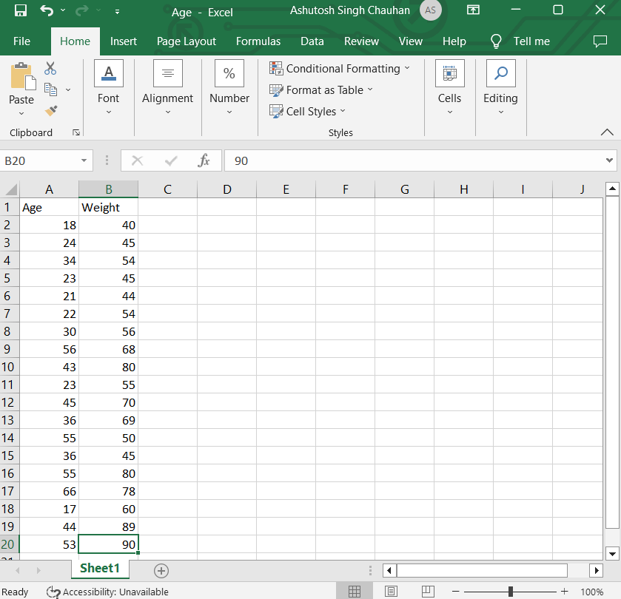

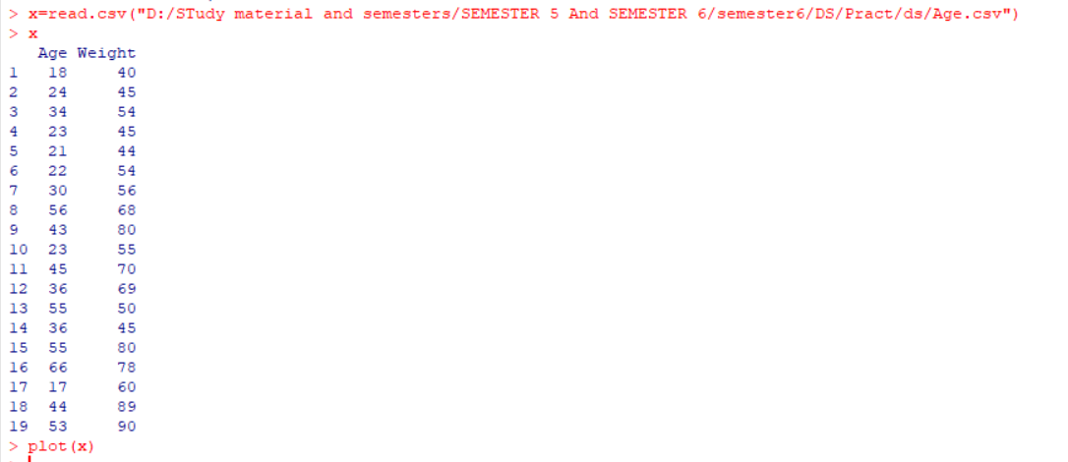

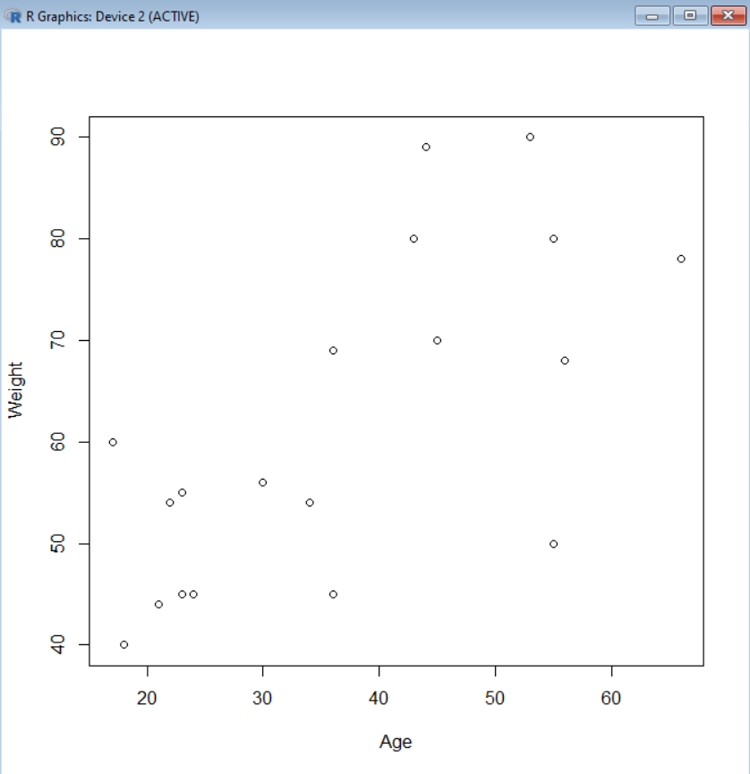



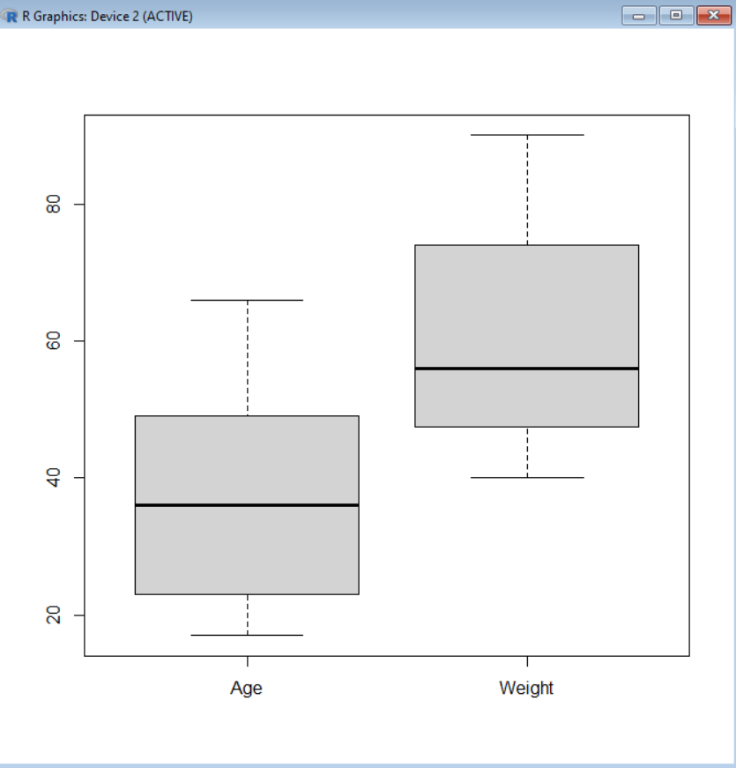

**Make the cluster**

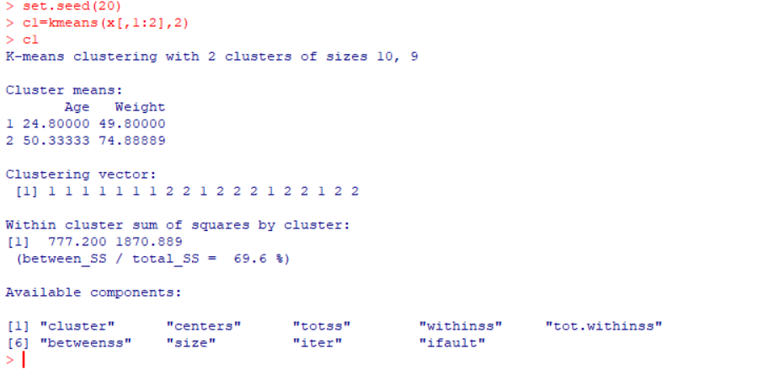

**#SHOW THE IRIS DATA SET**

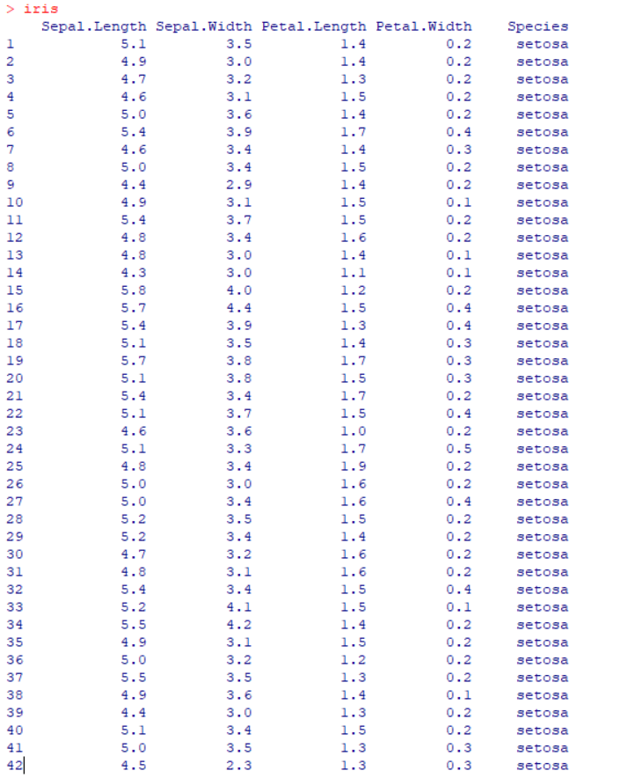



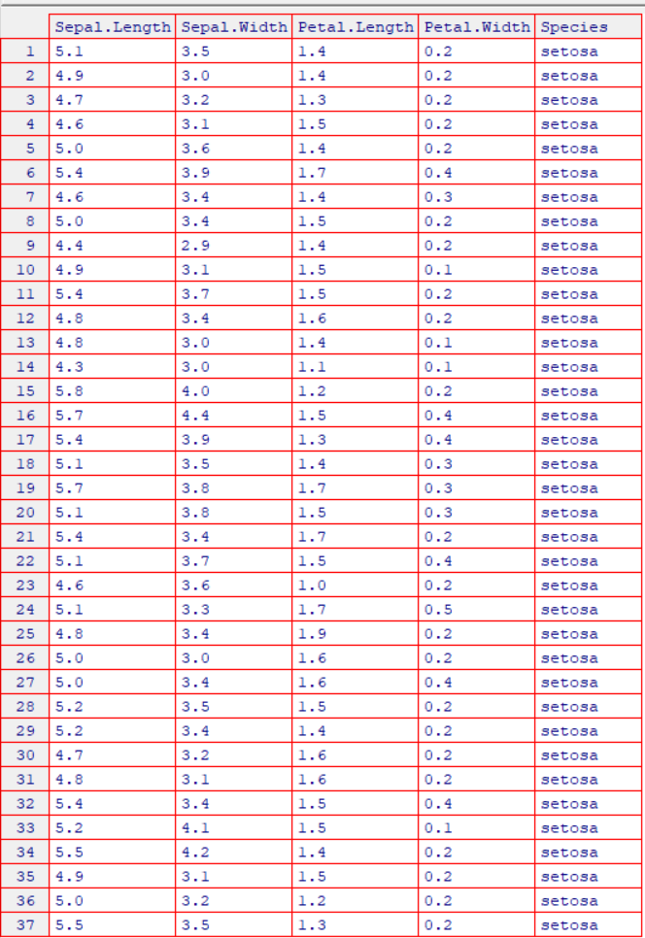

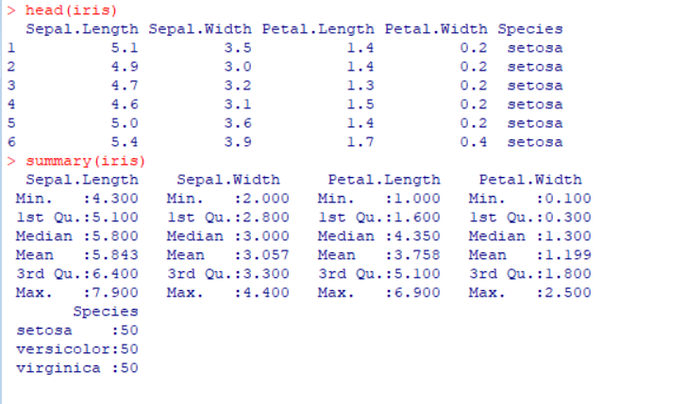

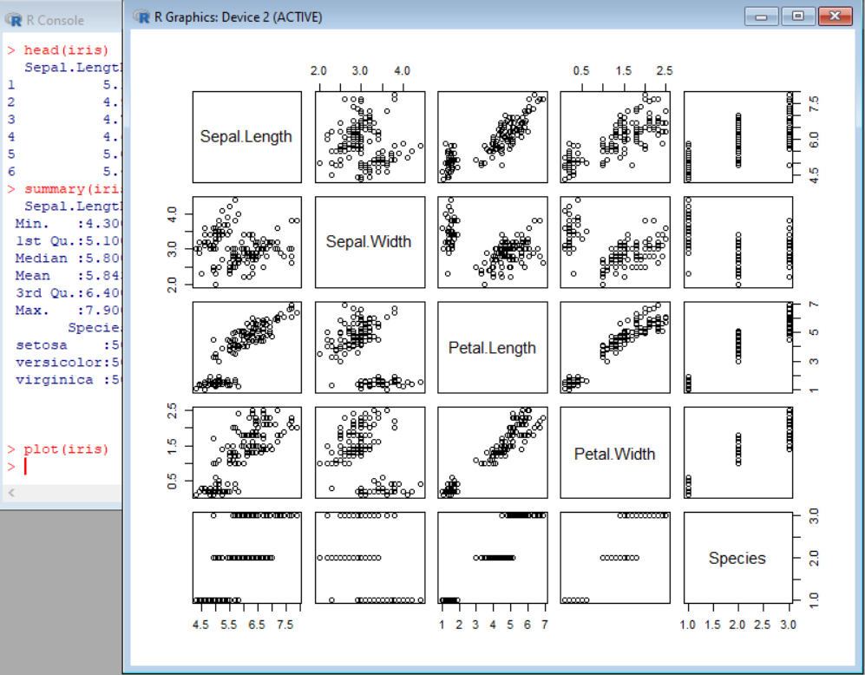

> plot(iris[,3:4])

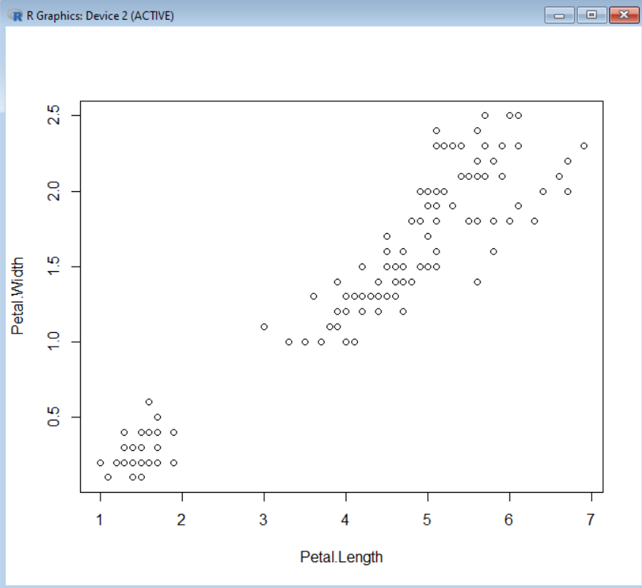

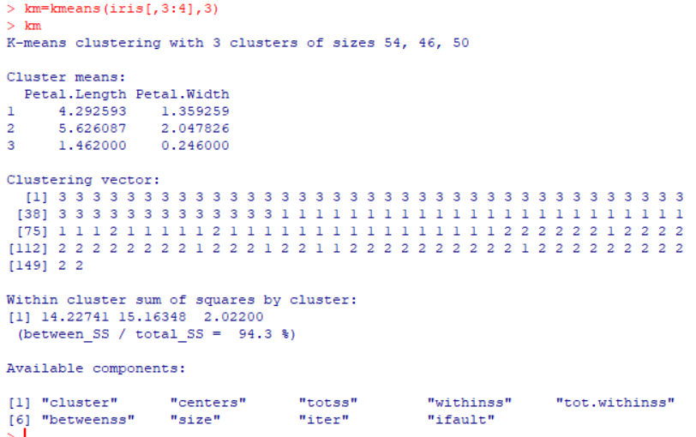

**PRINT CONFUSION MATRIX**

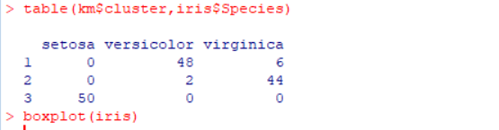

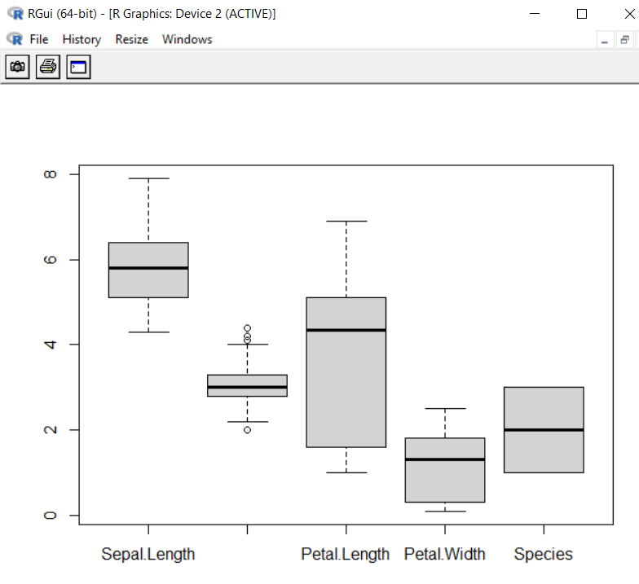

**CONCLUSION:** Thus we have implemented Clustering successfully. Clustering is used to identify groups of similar objects in datasets with two or more variable quantities. In practice, this data may be collected from marketing, biomedical, or geospatial databases, among many other places.

**Practical no.09**

**Aim:** – Demo of Time Series Forecasting

Theory:

Time series forecasting is a method in the statistics field to analyze historical data with a time component and create a prediction based on it.Some classic examples of time series forecasting methods are Moving Average, ARIMA, and Exponential Smoothing. These methods have been used for a long time and are still useful now because of how easy it is for users to explain the result — although with less accurate prediction.Whether you need a classical approach or a machine learning-driven model, many have developed Python packages to access all these methods. Some of the famous packages are Statsmodel, pmdarima, and sktime.However, the forecasting model is not limited to only the ones that are listed above because many great packages are worthy of consideration.

1. StatsForecast – It is a Python package that provides a collection of univariate time-series Forecasting models. What is unique about StatsForecast is the model provides fast training and is optimized for high-accuracy models. Also, the package offers several benchmarks we could use when training various models.

2. PyAF - PyAF or Python Automatic Forecasting is an open-source Python package to automatically

develop time-series forecasting models (either univariate or with exogenous data). The model was

built on top of Scikit-Learn and Pandas, so expect familiar APIs. The package also offers various

models to use in a few lines as much as possible.

3. NeuralProphet - It is a Python Package for developing a time-series model based on Facebook Prophet but with Neural Network architecture. The package is based on PyTorch and could easily be used with as few lines as possible.

Install packages using timeSeries and forecast

> install.packages(“forecast”)

> install.packages(“timeSeries”)

**And use both the libraries**

> library(forecast)

> library(timeSeries)

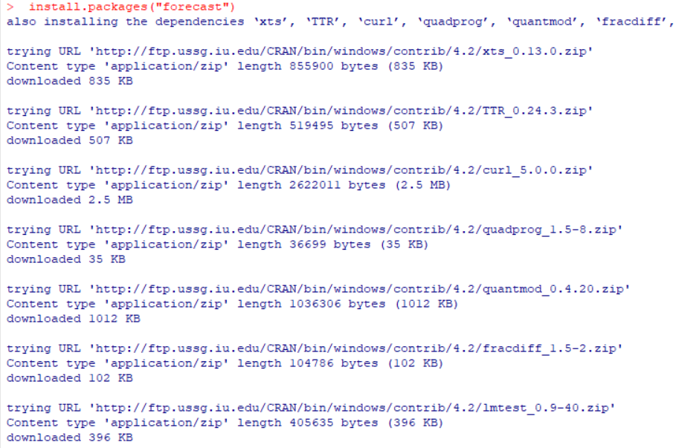

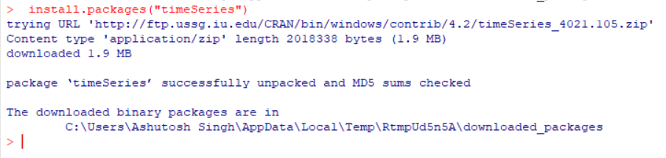

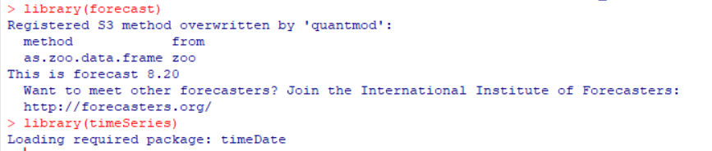 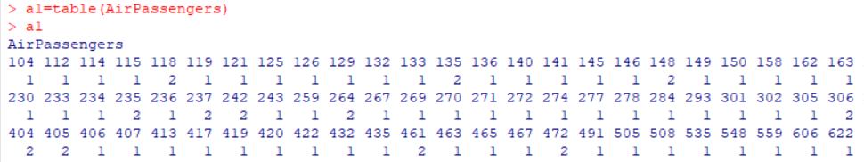

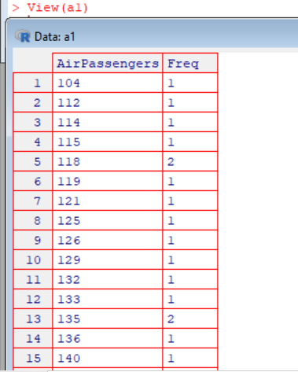

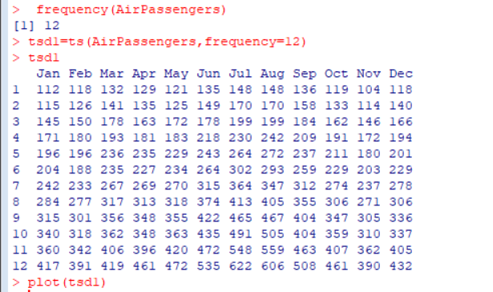

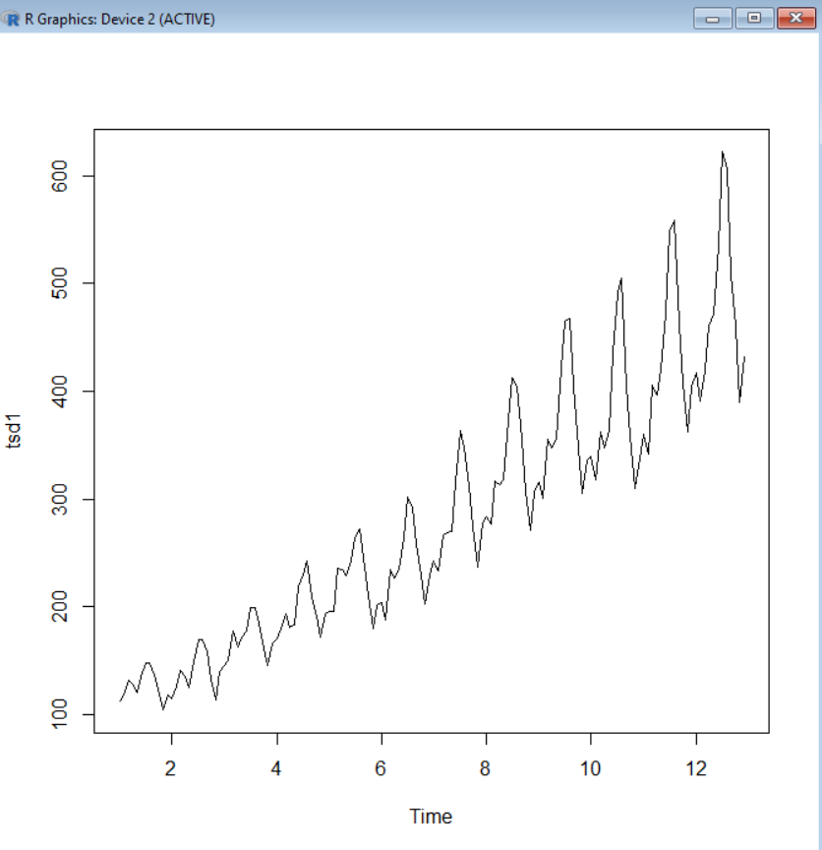

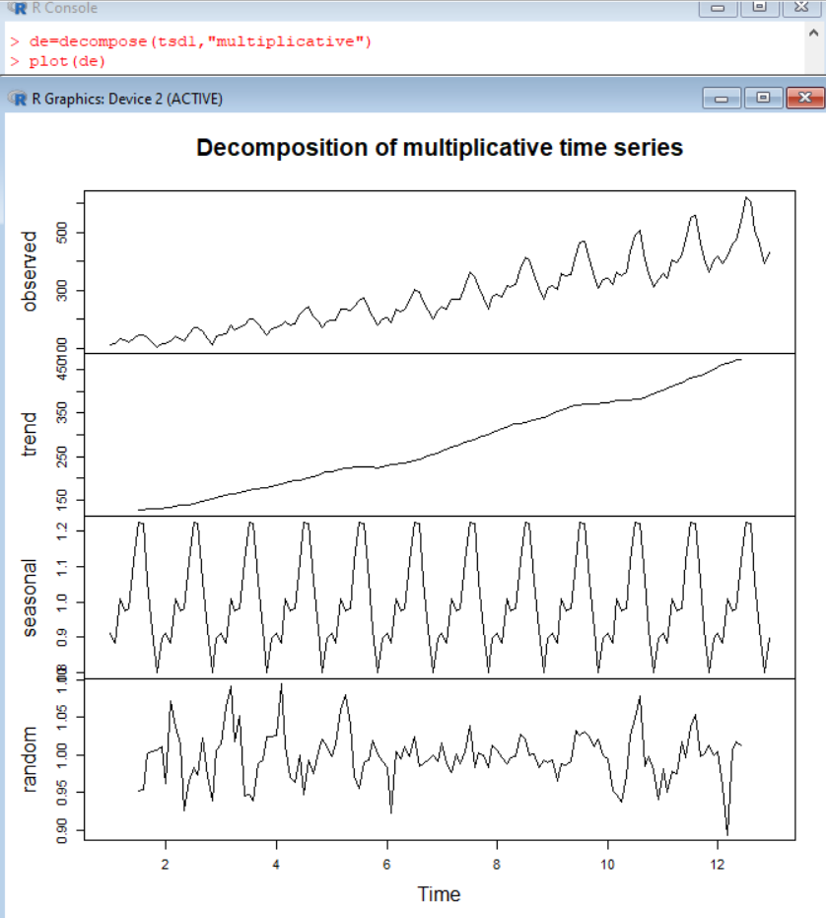 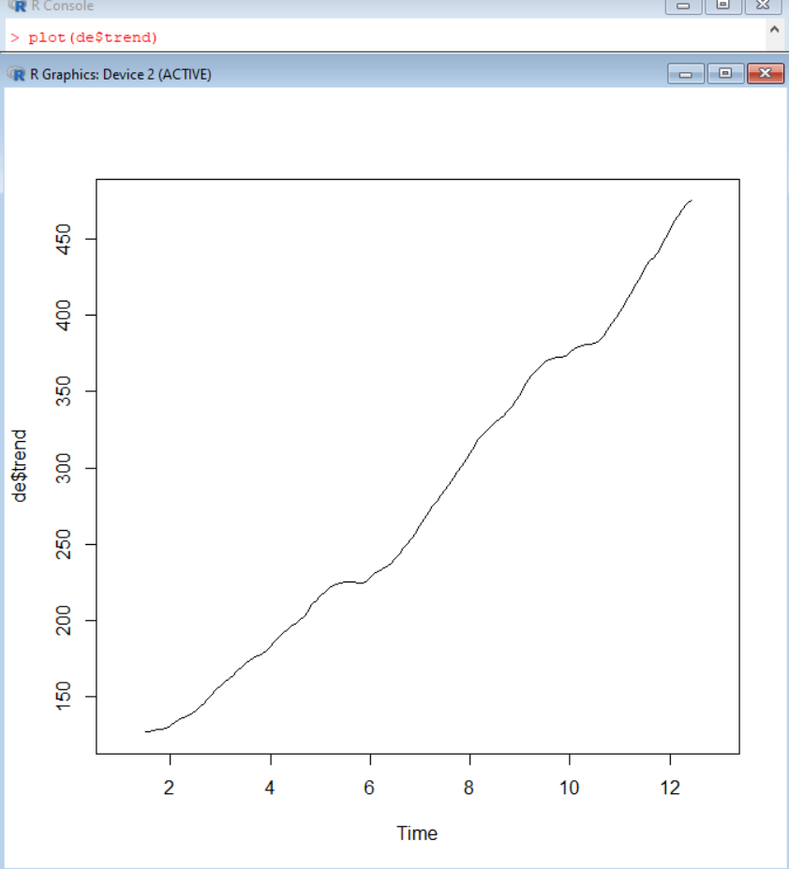

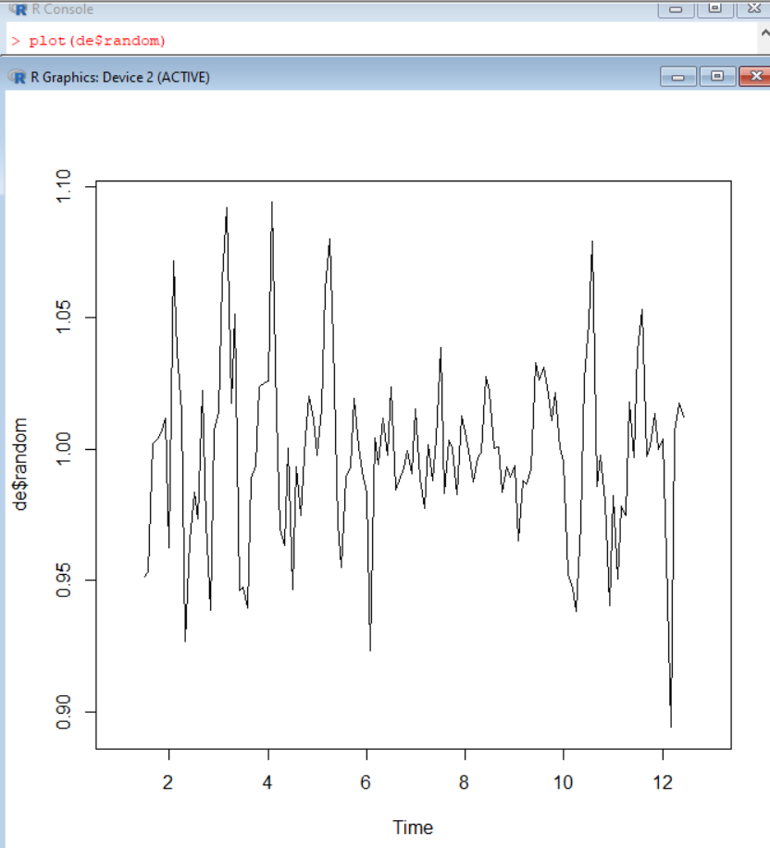 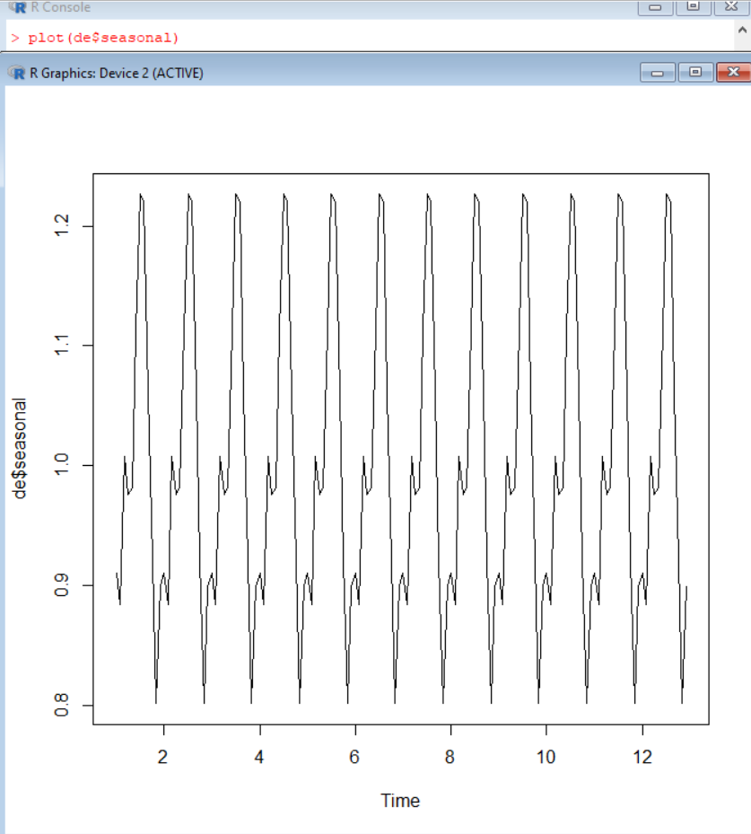

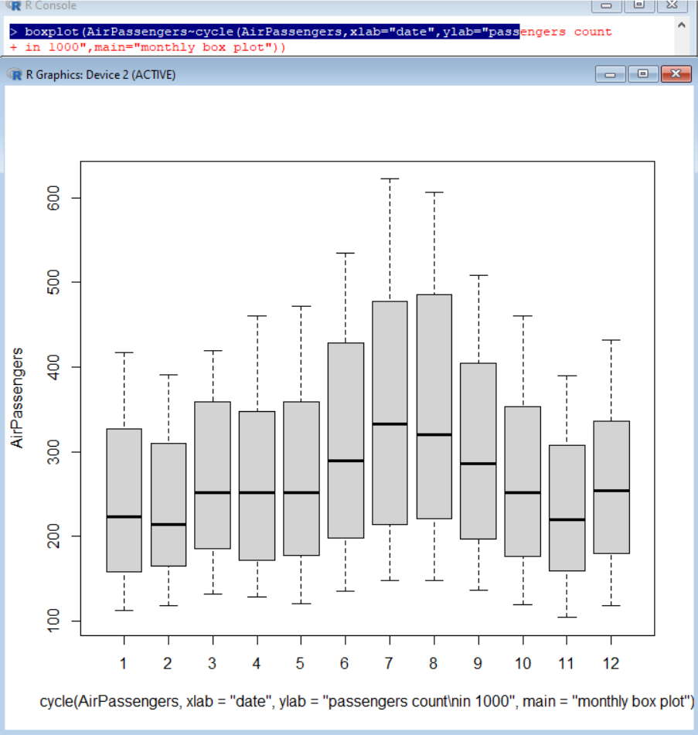 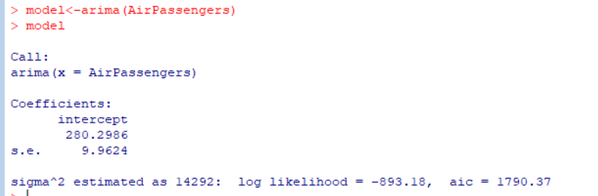

**Conclusion:** Thus we have implemented Time Series Forecast successfully.

**Practical : 10**

# AIM : Use of R Markdown and RStudio Cloud (Store mini project in RStudio Cloud).

**Theory:** [The R Project for Statistical Computing](https://www.r-project.org/) is is a free software environment for statistical computing and graphics. Here, we will setup a [cloud solution](https://rstudio.cloud/) made available by [RStudio](https://rstudio.com/).

R is the programming language and RStudio is the IDE (Integrated Developer Environment). To understand R versus RStudio, we can make an analogy to a car. If you think of R as the engine, then RStudio is the rest of the car. I.e. RStudio allows us to interact with R in a seamless manner.

Create account in RStudio Cloud.

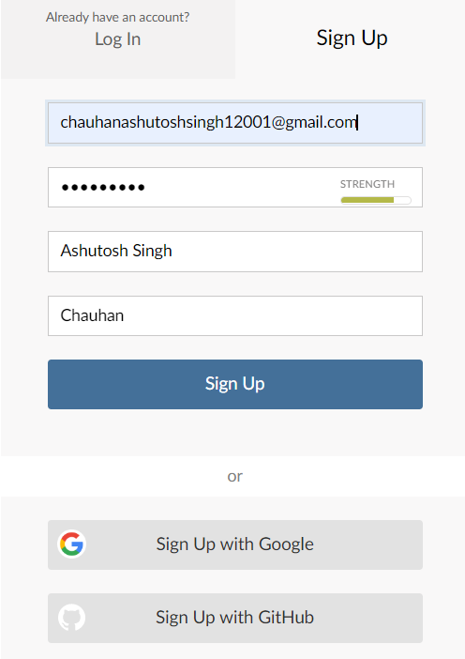

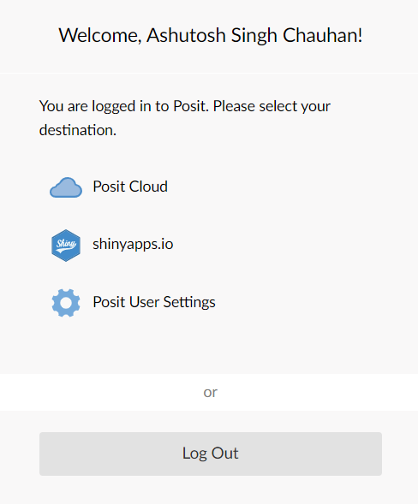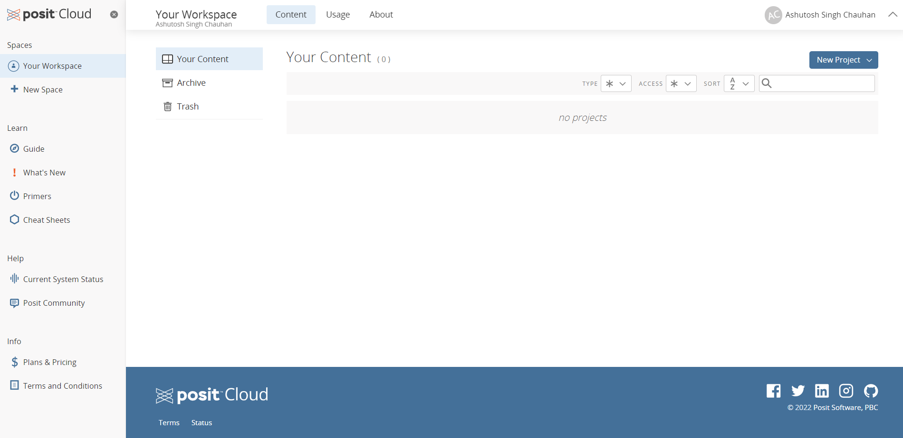

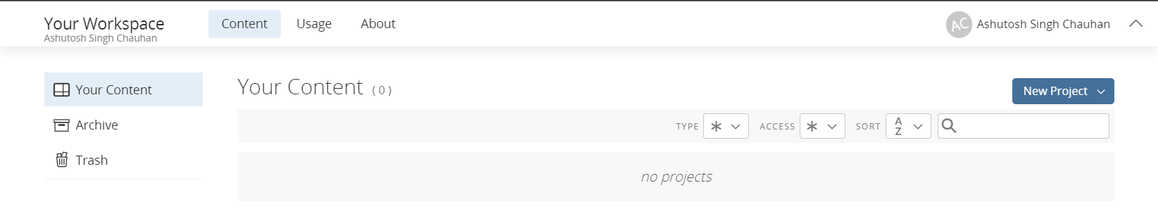

**1**. **The latest version of modEvA should be installed**

install.packages("modEvA")

2**. Make sure the package is loaded**

**> library(modEvA)**

3. Performing a model analysis

> data(rotif.mods)

> help(rotif.mods)

> names(rotif.mods$models)

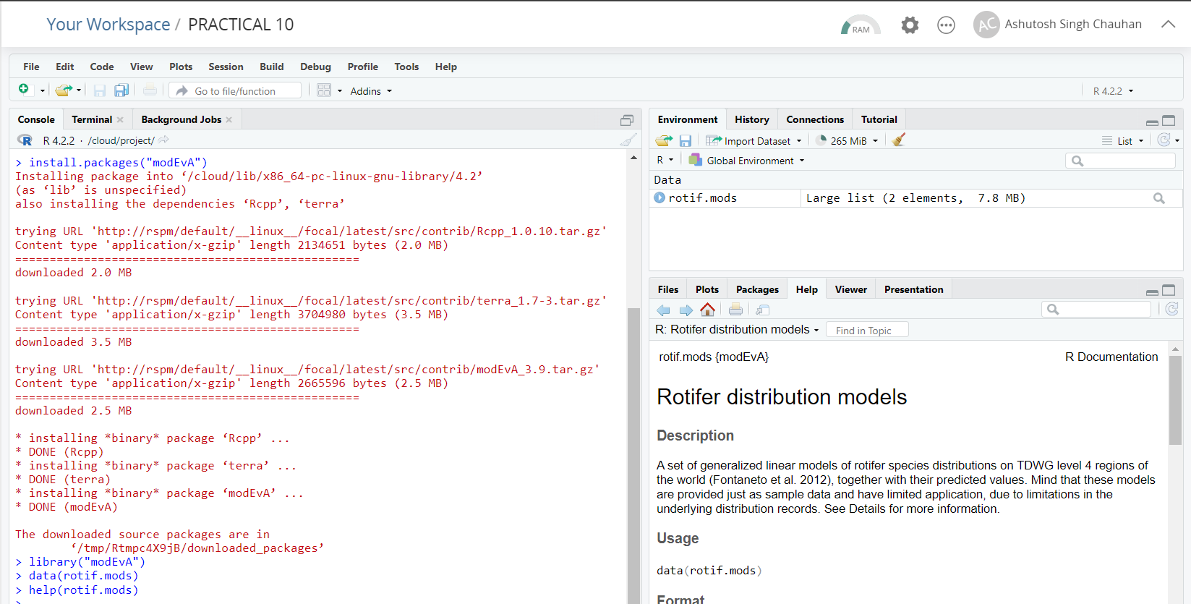

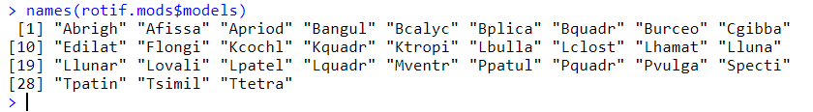

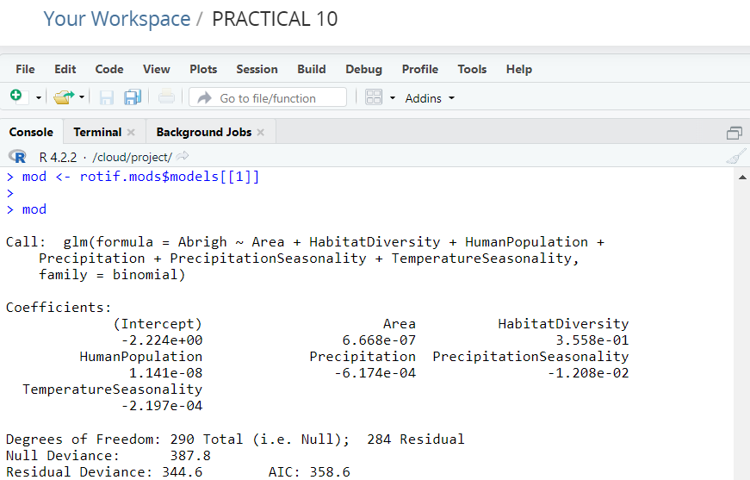

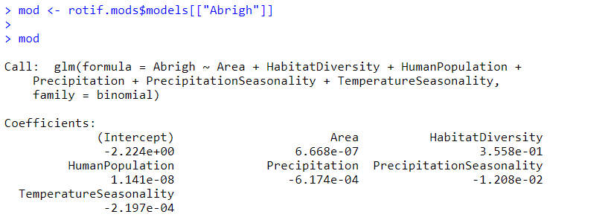

|  |
| --- |
| > mydata <- data.frame(observed = mod$y, predicted = mod$fitted.values)  > plotGLM(model = mod, xlab = "Logit (Y)", ylab = "Predicted probability", main = "Model plot") |
|  |
|  |

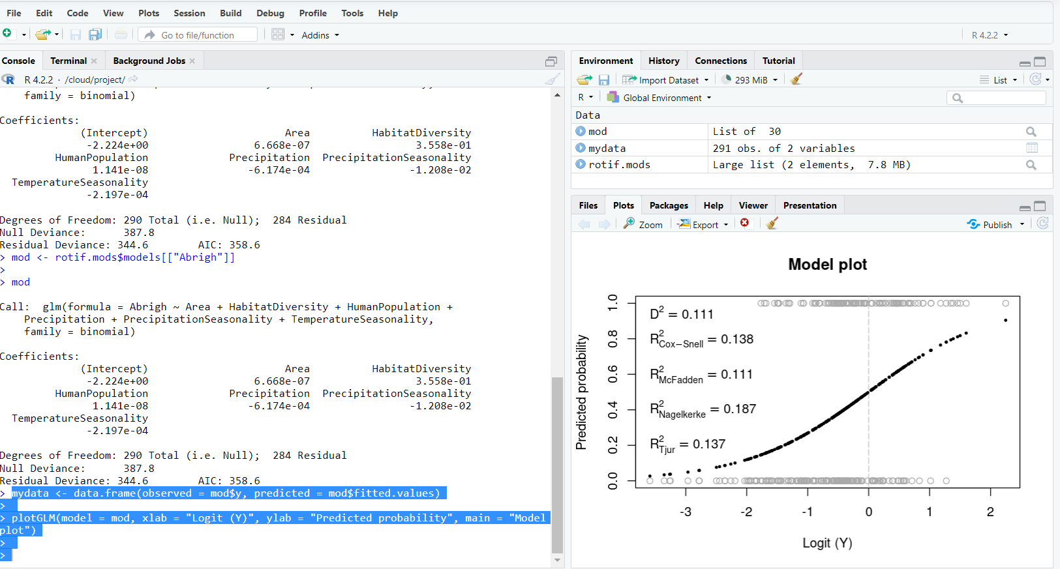

>plotGLM(obs = mydata[ , "observed"], pred = mydata[ , "predicted"], xlab = "Logit (Y)", ylab = "Predicted probability", main = "Model plot")

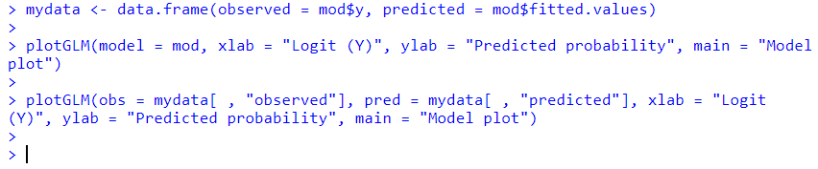

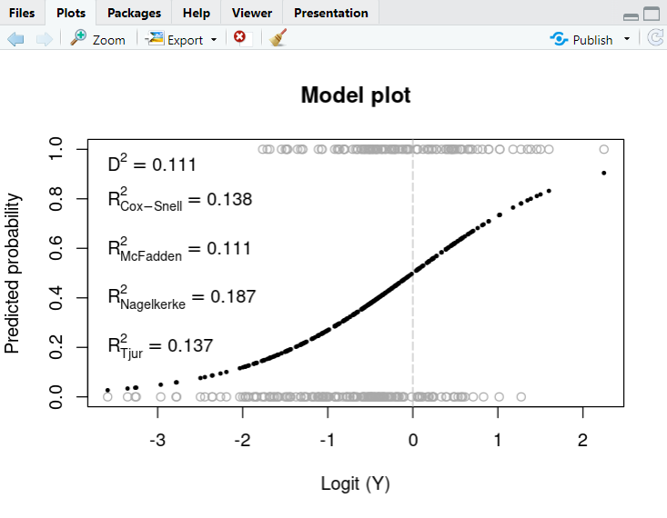

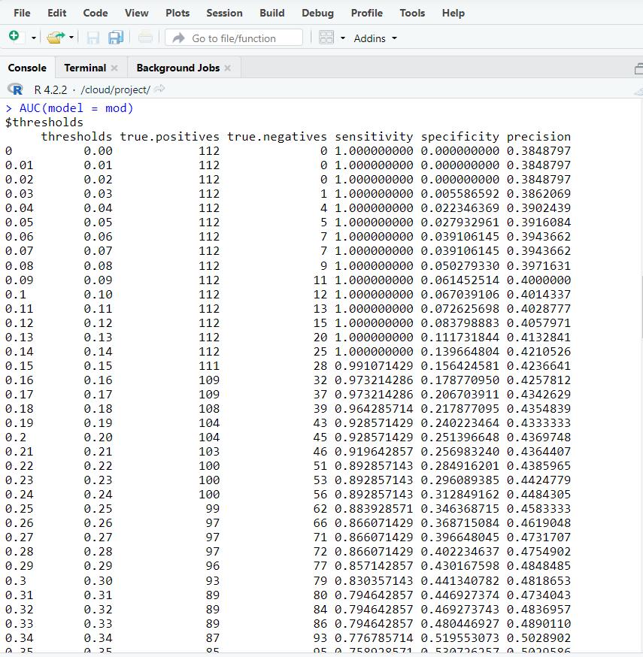

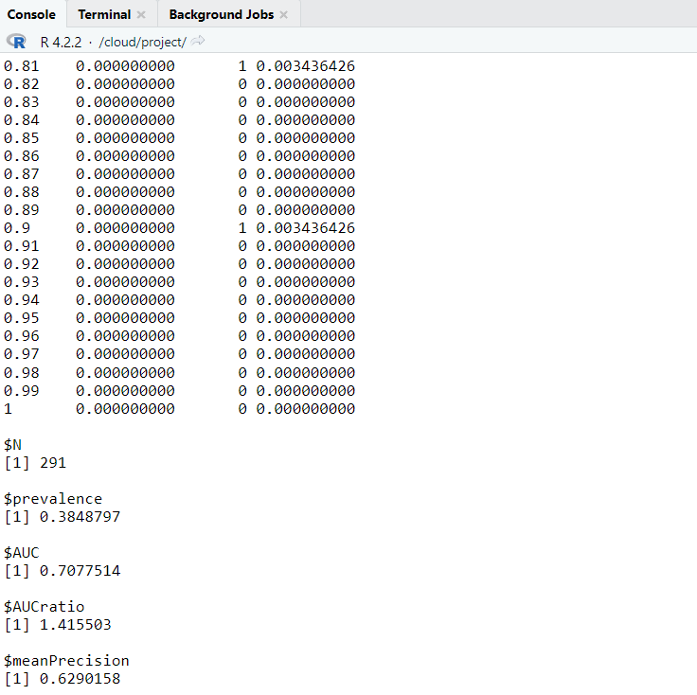 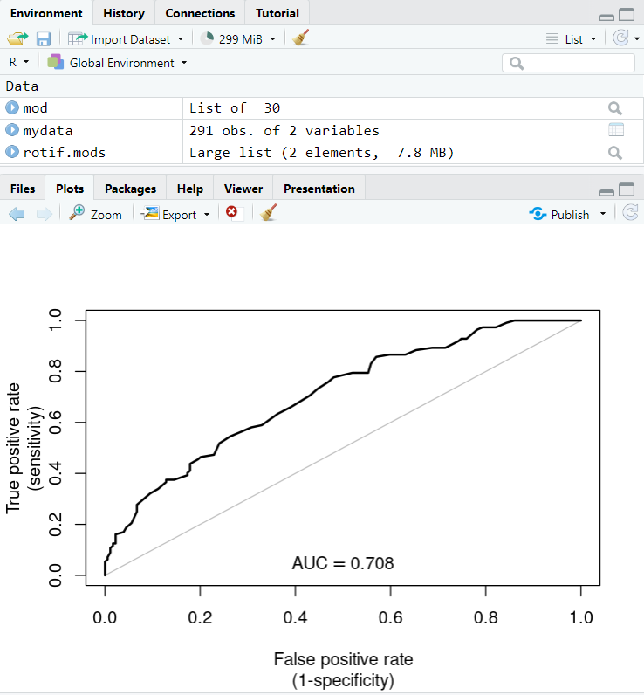

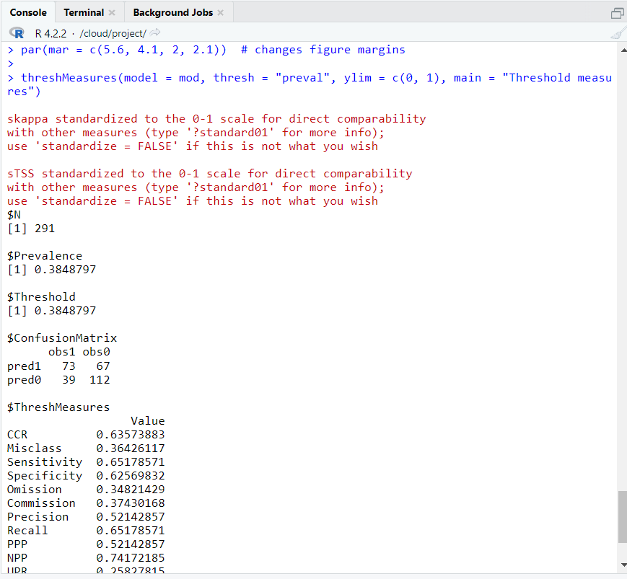 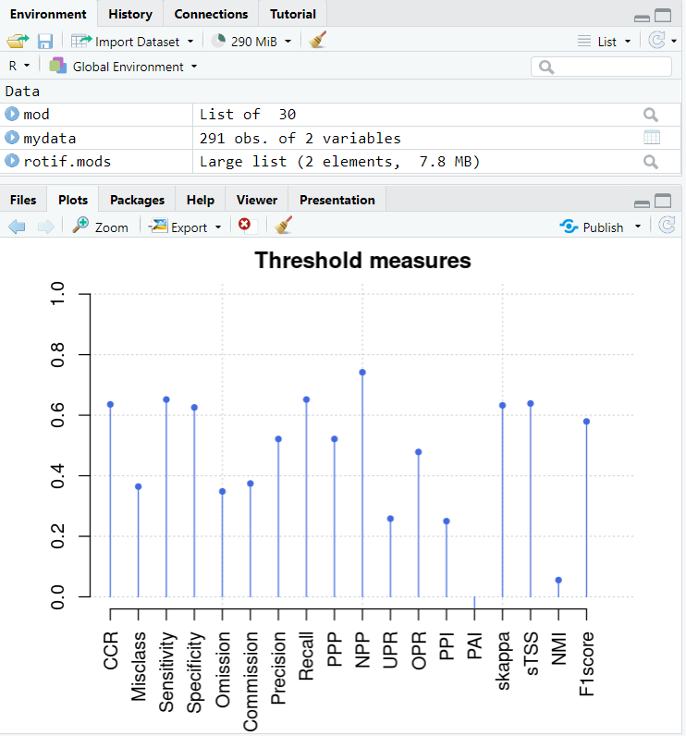

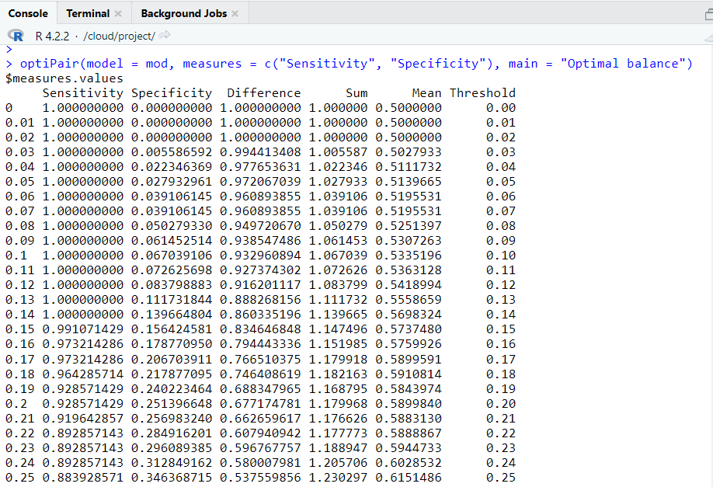 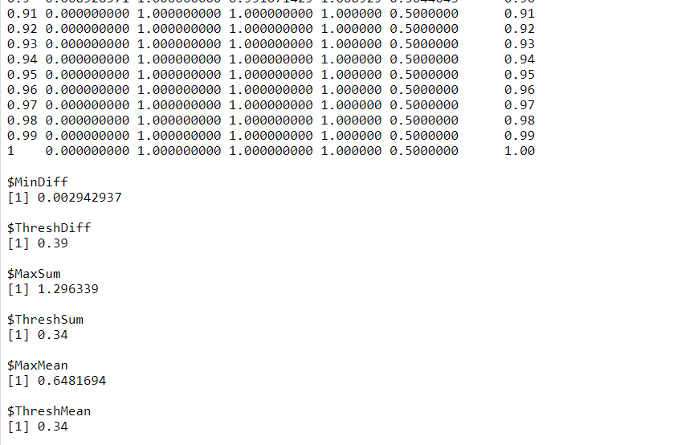

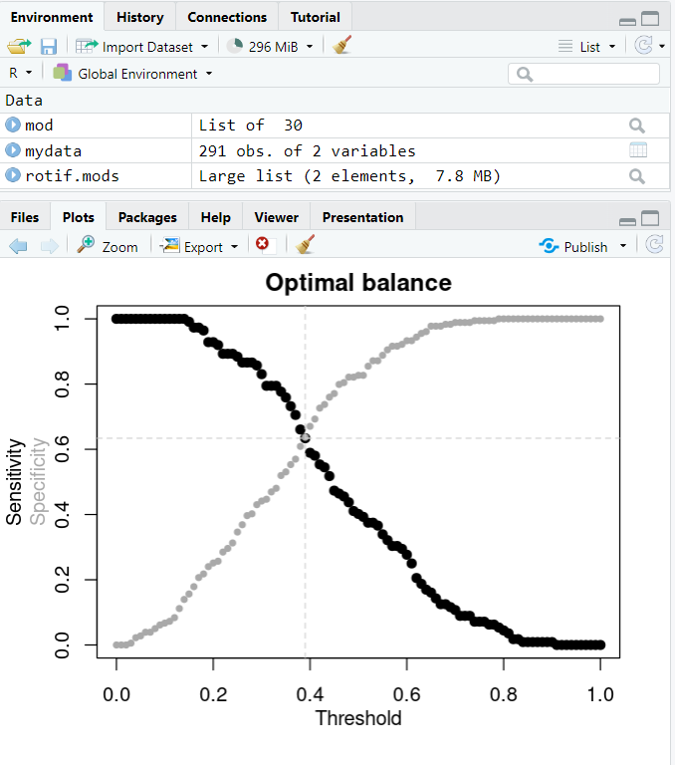 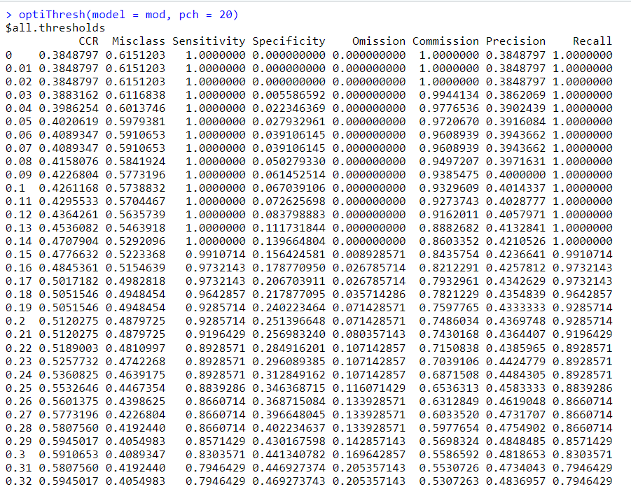

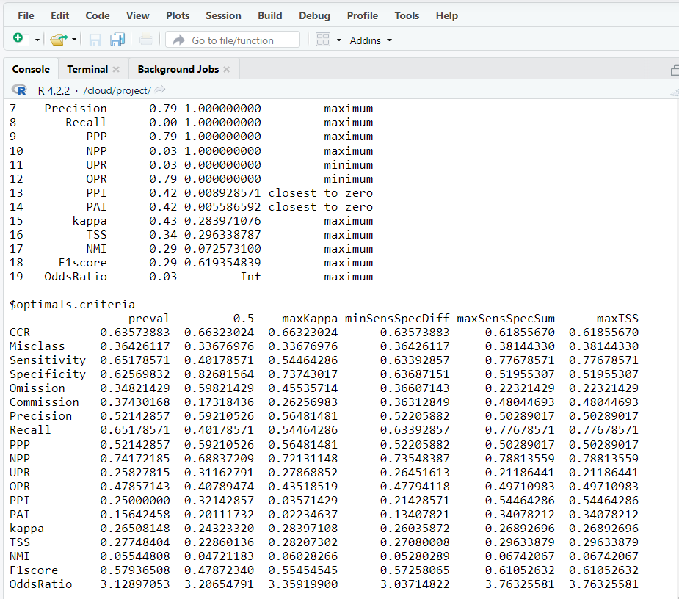

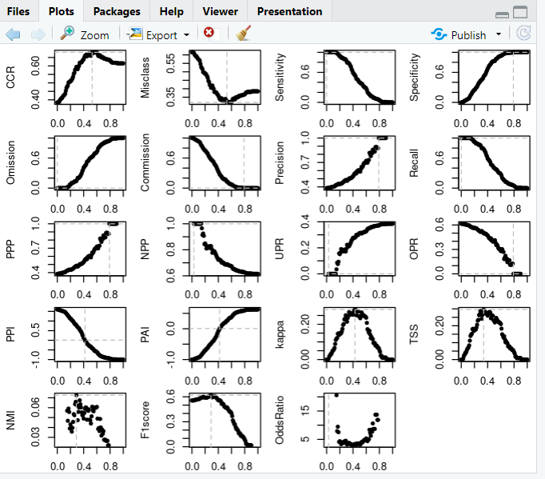

**Assessing model explanatory power, fit and calibration**

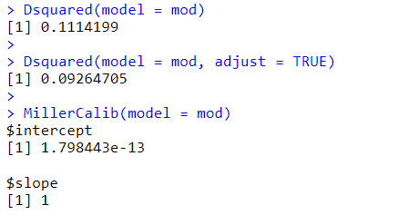 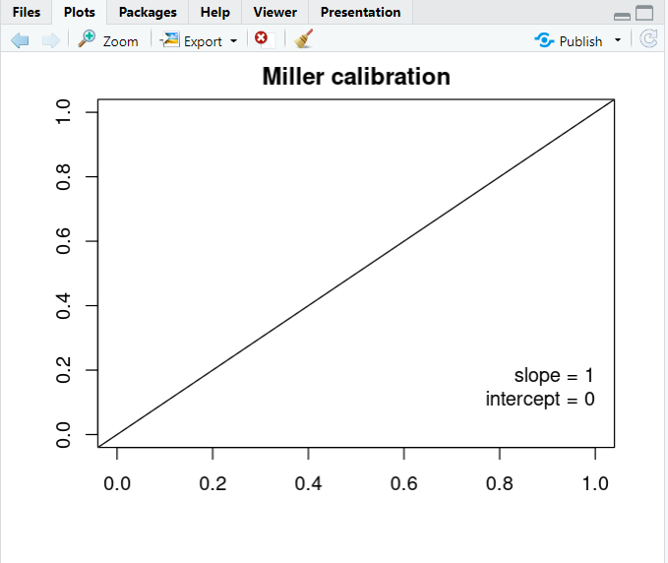

>HLfit(model = mod, bin.method = "quantiles", main = "Hosmer-Lemeshow GOF, quantiles")

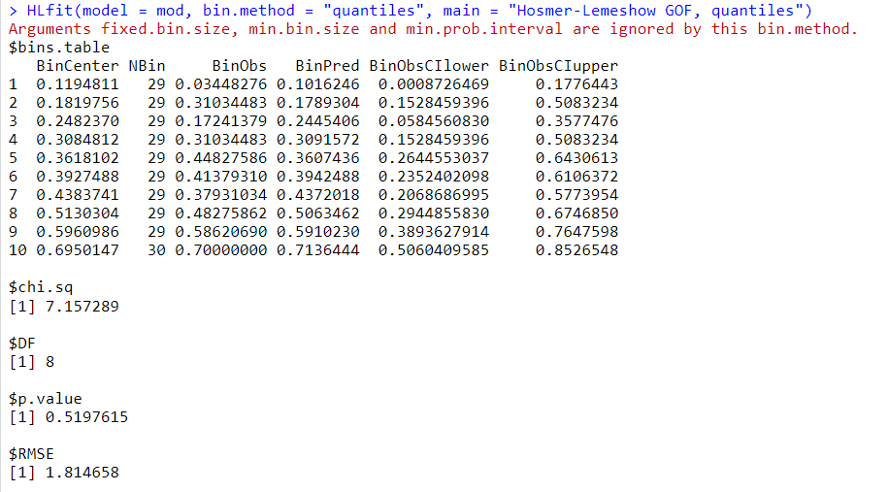 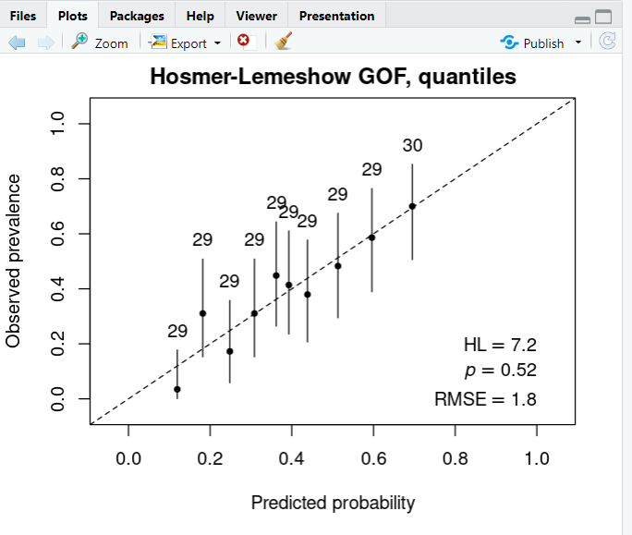

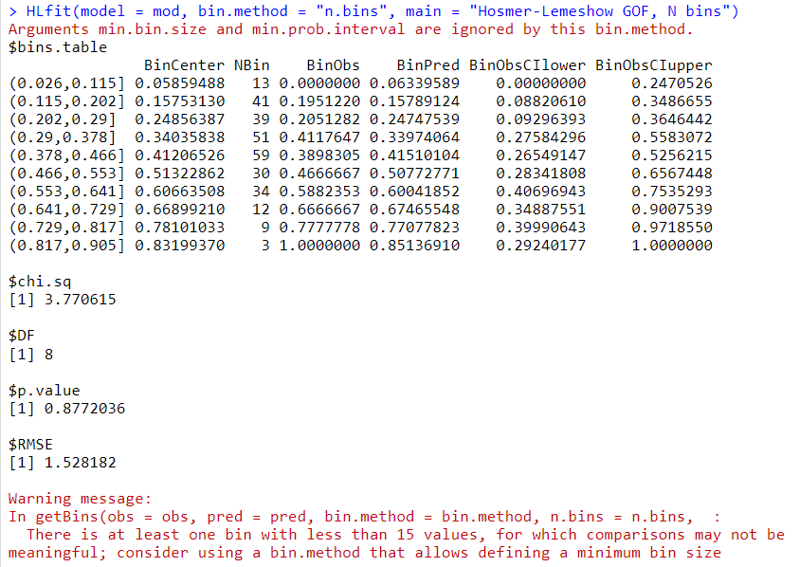 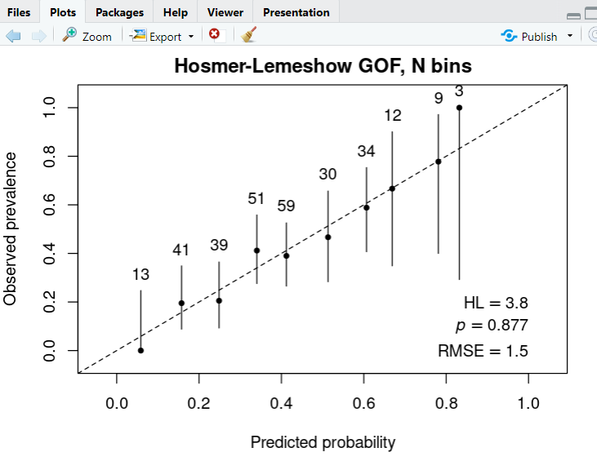

## **Evaluating multiple models**

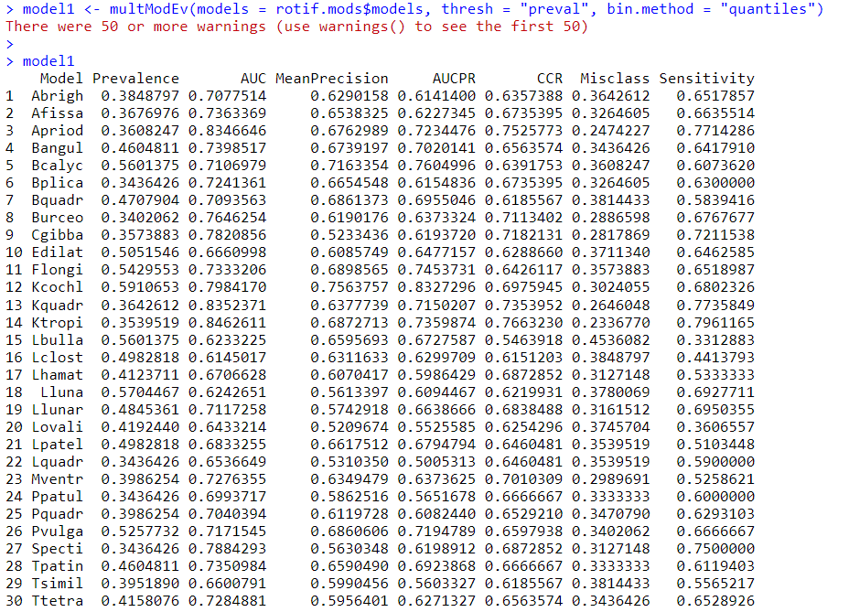 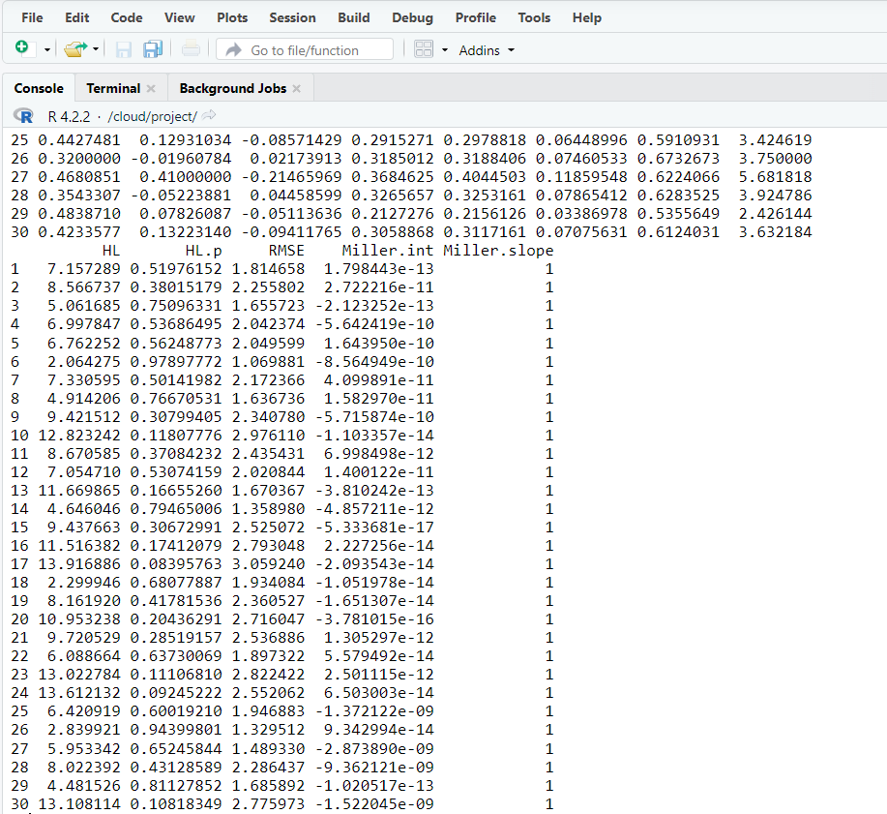

 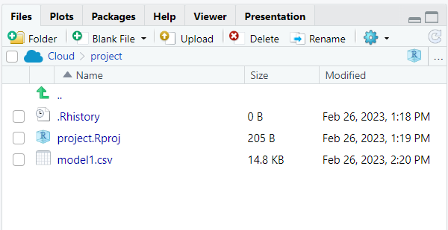

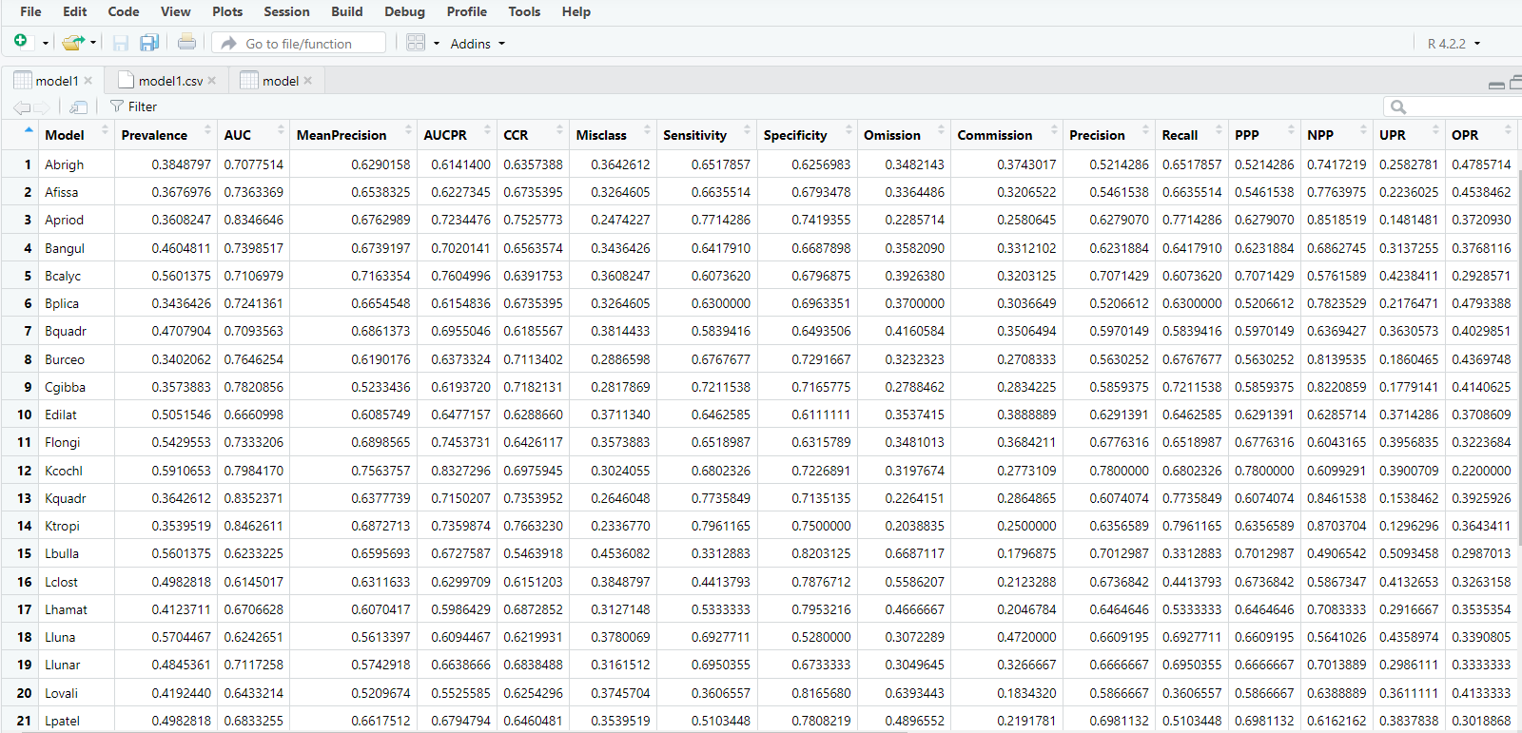

**Conclusion :** Data visualisation in R and RStudio makes it possible to easily use basic plotting functions, or apply more advanced functions through packages.As you must have noticed throughout this week, the undeniable **added value** of R/RStudio compared to the more classical resources such as **Excel**, is the ability to produce **publication-ready graphics**. For this, you can either use default functions and options, which already produce a highly controlled output quality, or you can also pre-define advanced options and use them in variables.